E-Learning Paper Prototype – Telephone Etiquette and Listening Skills
Amy Dean
EDCI 56900
Purdue University
February 14, 2016

Table of Contents
Subject and Learning Context……………………………………………………………………3
Project Scope………………..……………………………………………………………………3
Target Learner Analysis…….……………………………………………………………………3
Intended Instruction………………………………………………………………………………4
Learning Environment……………………………………………………………………………4
Site Map…………..………………………………………………………………………………6
Storyboard………...………………………………………………………………………………7
Additional Content...……………...………………………………………………………...……31
Merrill’s Five Star Instructional Design Evaluation …………………………….………………42
References………………………………………… …………………………….………………48

Subject and Learning Context:
This e-learning course, Telephone Etiquette and Listening Skills is a definite need for new employees coming on board with our payroll company, Paycor. Most of the employees at Paycor begin their client relationship over the phone, where a majority of the day is spent. The goal of this course is for new hires to understand the importance of having impeccable phone skills throughout the entire interaction with Paycor clients.
Project Scope:
For this course, it will be designed as a self-paced e-learning course which will be hosted on our internal learning website. This topic is one of six which will be covered in the series of the Paycor WOW factor. This WOW factor helps Paycor employees stand apart from the rest, and give our clients a “remarkable” experience, (The COR, 2014). This specific topic will include five learning objectives new employees will be expected to meet following course completion, which includes learners being able to identify the benefits of giving superior customer service, understanding how to limit distractions, and practice active listening.
Target Learner Analysis:
The target learners for this e-learning course will be for new Paycor employees since a majority of client interactions take place through phone conversations. Since this course will be self-paced, and a familiar subject it will allow learners to digest information at their own pace, while building upon their current phone skills. The expectation is this course will help Paycor employees bring their phone skills to a superior level.

Intended Instruction:
This course will be a standalone self-paced module which will include samples of real-life phone interactions between Paycor employees and clients. I think sometimes humor is something people are afraid to include in e-learning courses but with this topic, I plan to include some short videos on humorous phone calls between clients and employees. Since phone interactions are something that have been around for a while, it will be critical to keep the learners engaged with humor, and clear, specific ways to improve client interactions. In order to enter the course, they must have internet access and be a current Paycor employee. Throughout the course, there will be some check points where learners will complete some games or questions on the given learning objectives. I also want to include a pre/post assessment to gauge what they think is important in a phone call before and after the course.
Learning Environment/Proposed Delivery Method:
Since I am working with Paycor on this training, I will be utilizing Adobe Captivate as the e-learning platform. I have worked with this product before, and have found it challenging to use in the past. I am also hoping to include some different technologies to embed in the training. In regards to the LMS, I will be using Paycor’s current technology. Paycor employees will access the training through our internal website. I have had conversations with our manager of learning on what technologies they are using, and how it will be hosted for employees.
Learning Objectives: (Utilizing Robert Mager’s Theory)
- Given real-life recorded client phone interactions with a Paycor associate, learners will successfully identify specific client needs.
- Understand how to demonstrate a professional image during client phone interactions by applying at least three ways to provide remarkable service to the client.
- Given a client phone interaction, learners will understand how to limit distractions and practice active listening skills while on the phone with clients.
- Given a specific product issue, learners will understand how to incorporate confidence, empathy statements, and the benefits of summarizing each phone call.
- Learners will recognize the importance of effective follow-up and logging the client interaction.
Learners must be able to understand how to effectively identify the reason a client would be calling, quickly resolve the concern or issue, and verify their needs were heard. From the internal side, the learner needs to limit distractions while on the phone, take thoughtful notes during the call, and finally log the call properly. They may struggle with the empathy portion of this training. The associate should always show empathy to the client needs and concerns. The clients have businesses to run, and do not want to spend a majority of their day on the phone with their payroll company.
Learners will complete a pre-assessment and post assessment focusing on what they knew on phone etiquette before and after the e-learning course. The goal would be for their knowledge and comfort to increase on being able to confidently take phone calls with clients. Learners will be able to reach out to the learning team if they are having challenges with the course. Paycor has a dedicated IT support team along with a learning team to support such challenges.

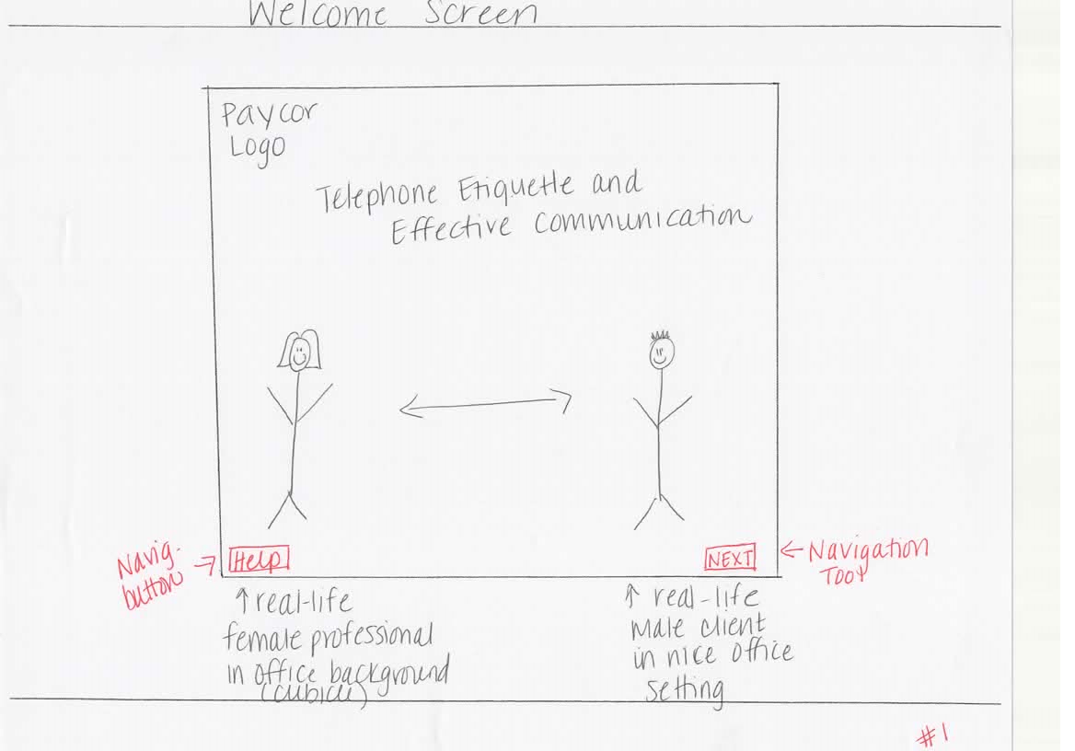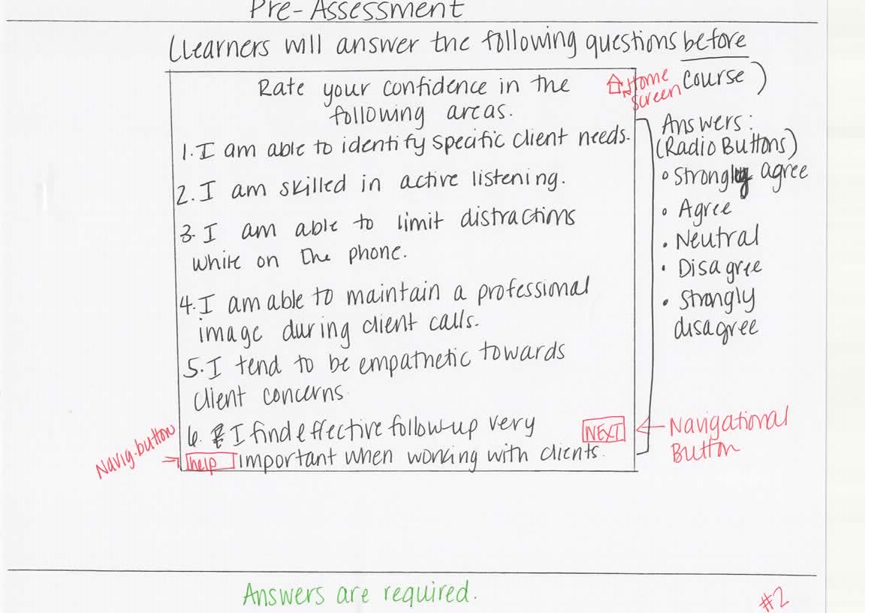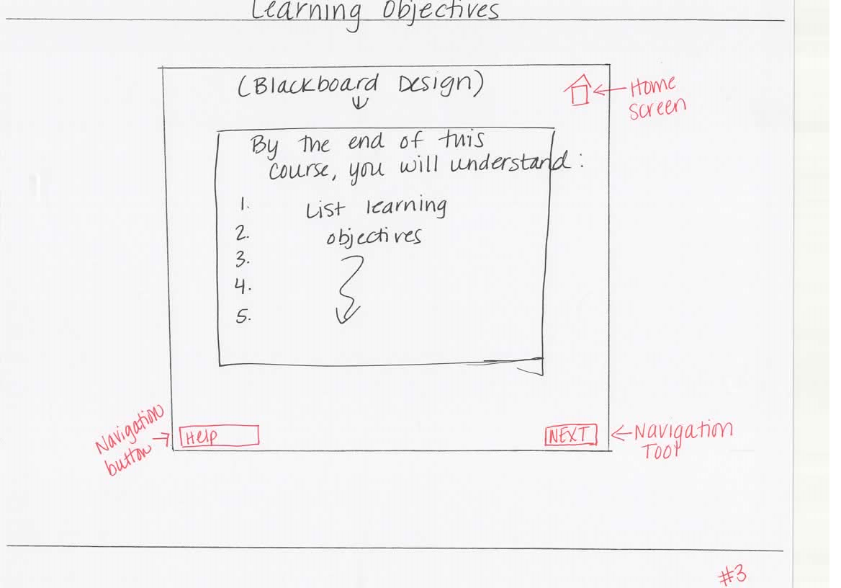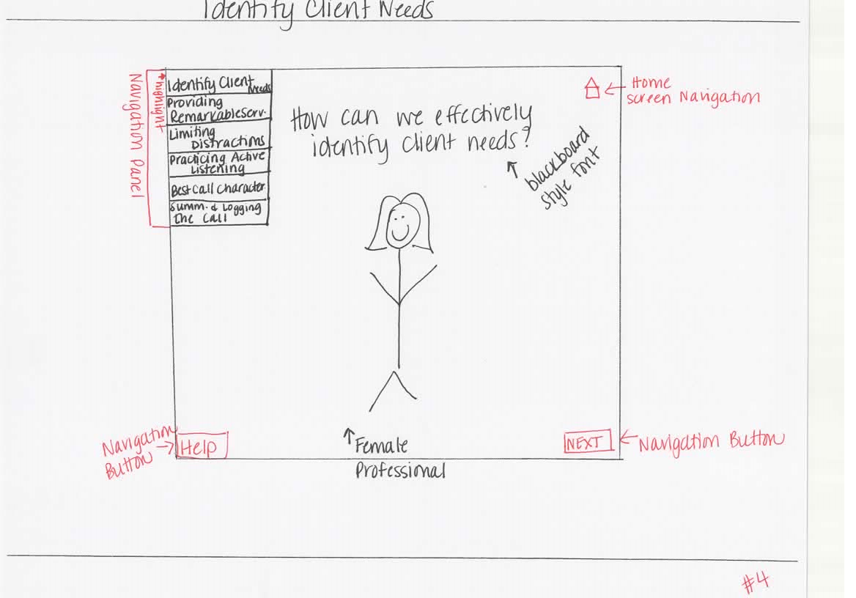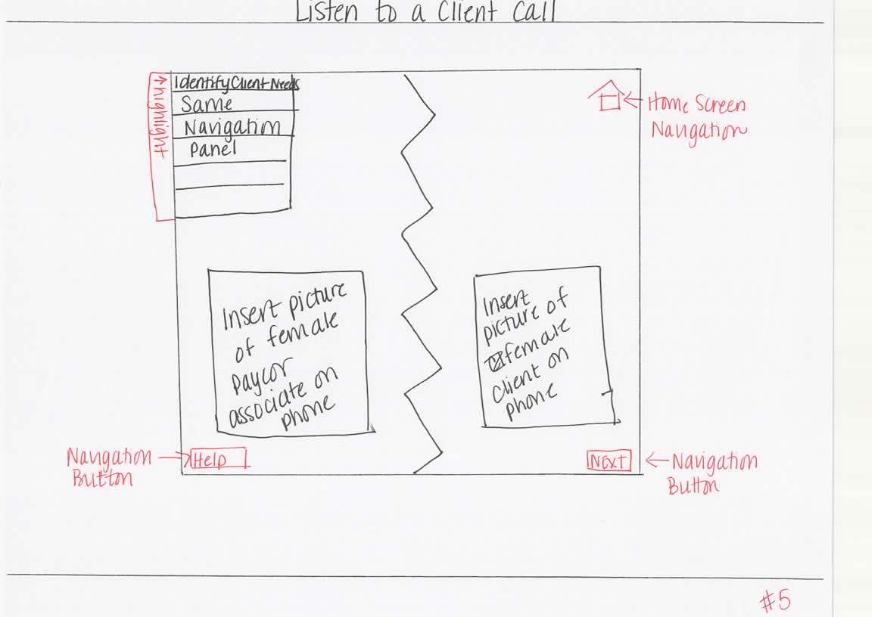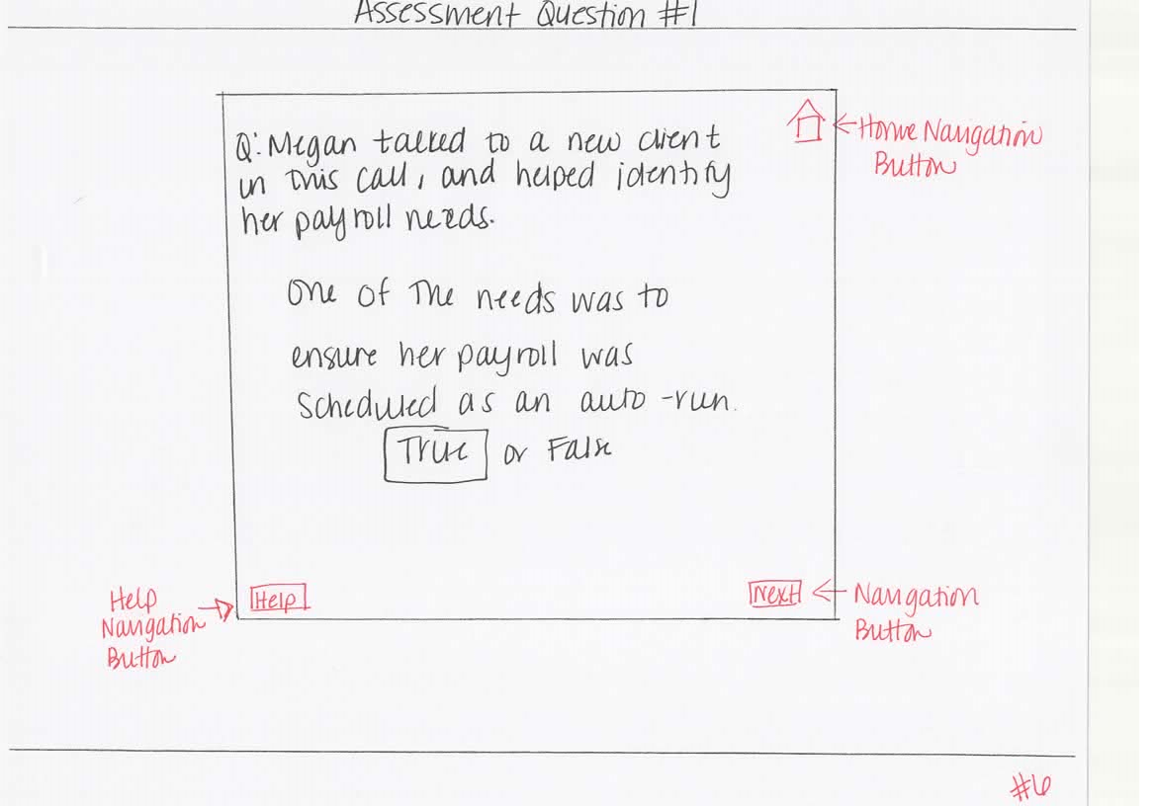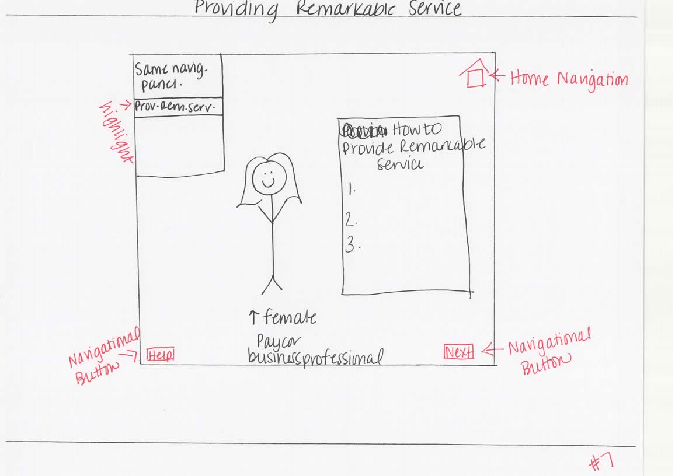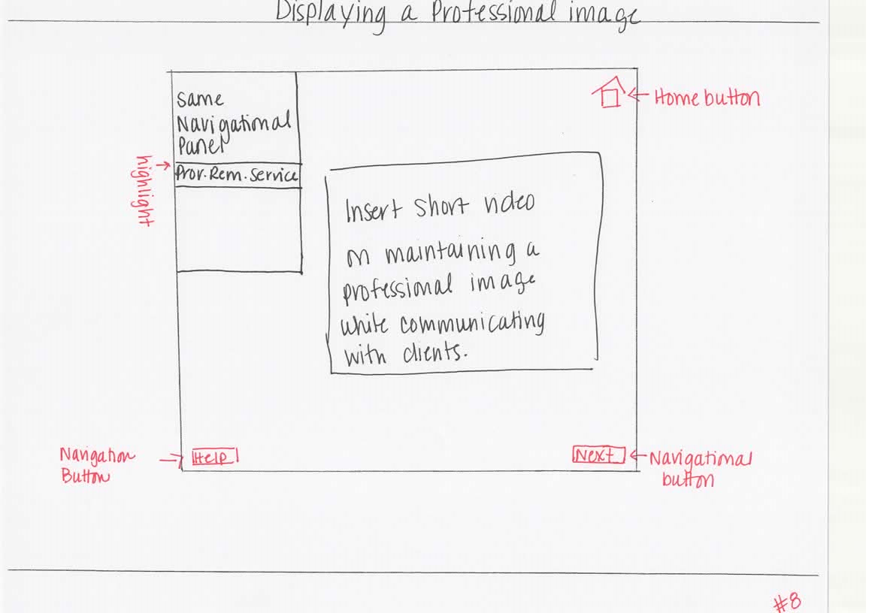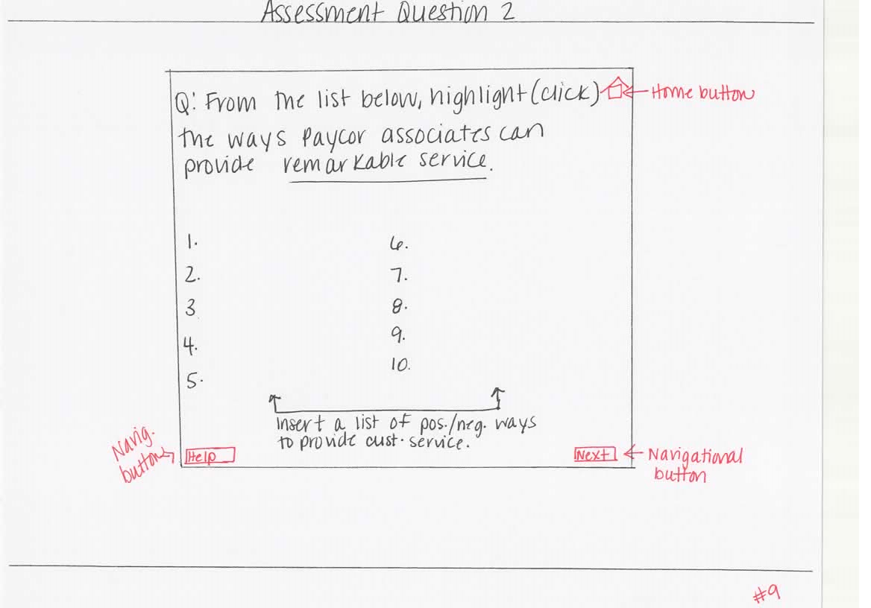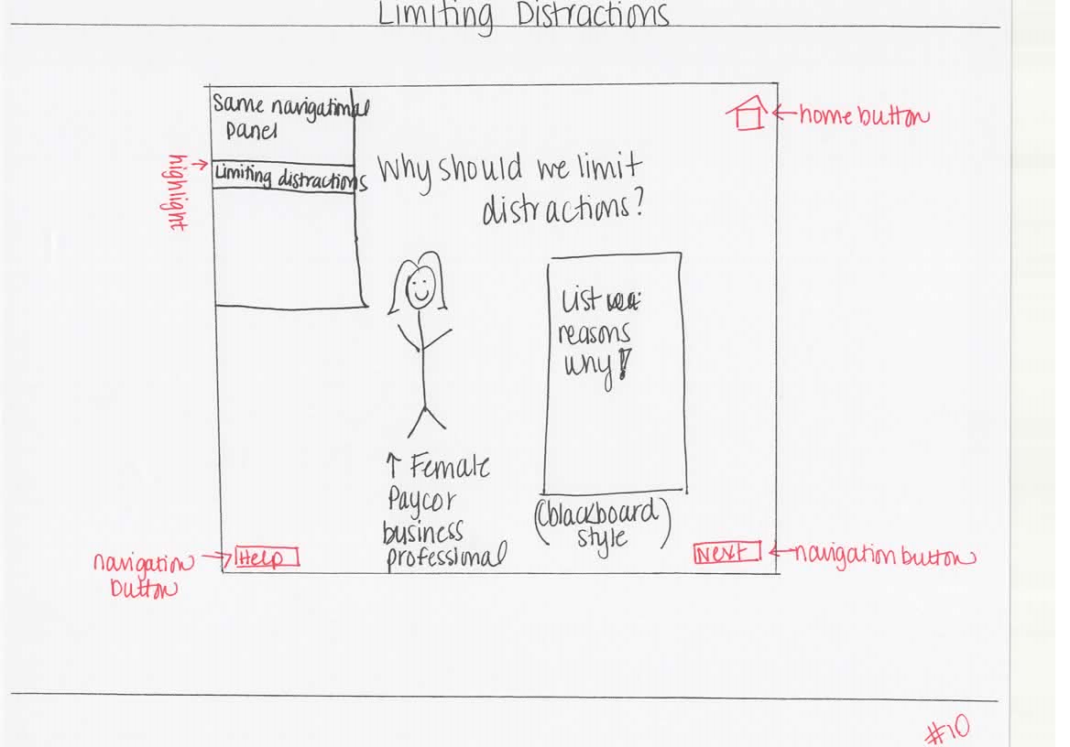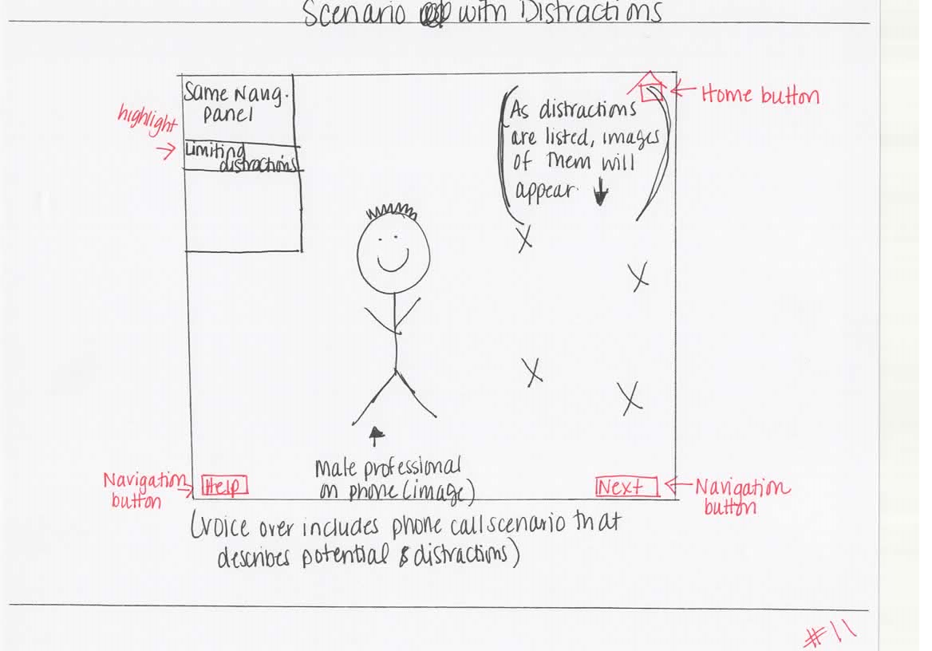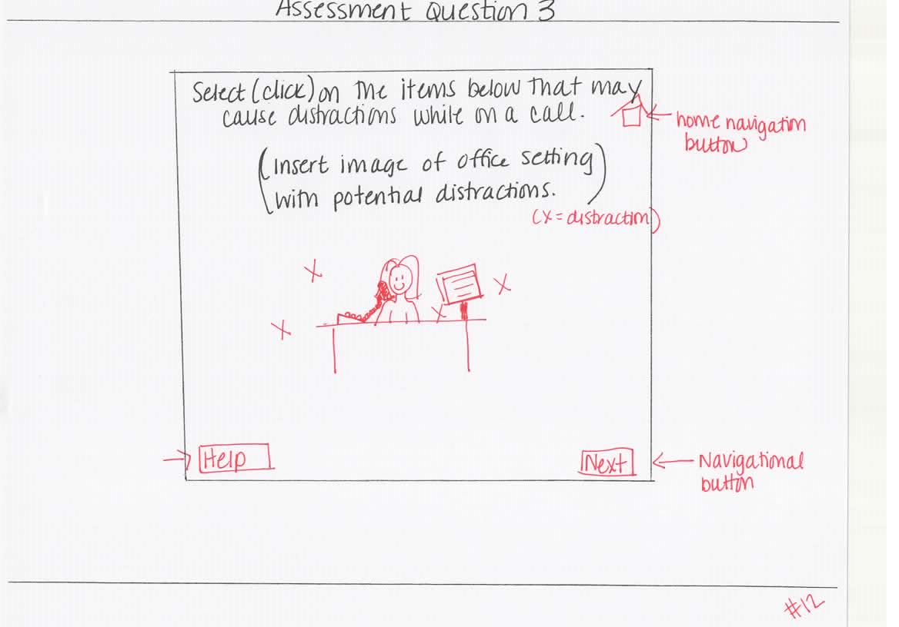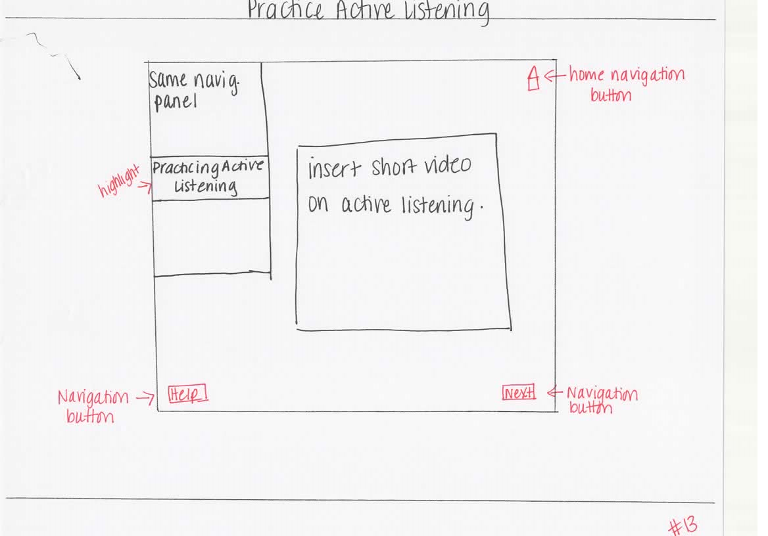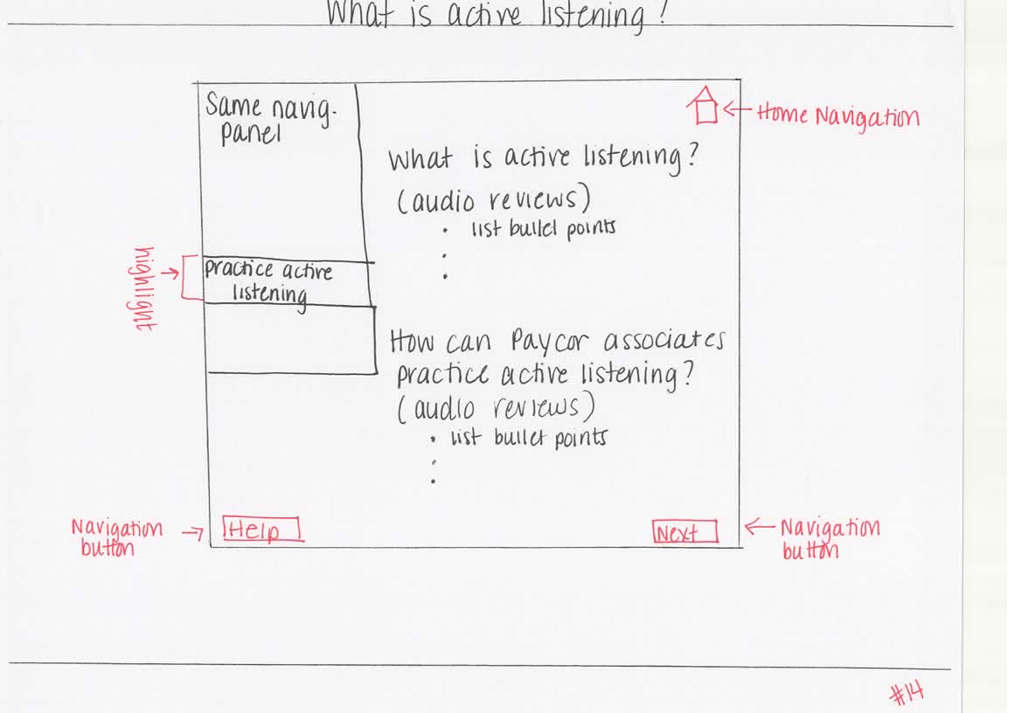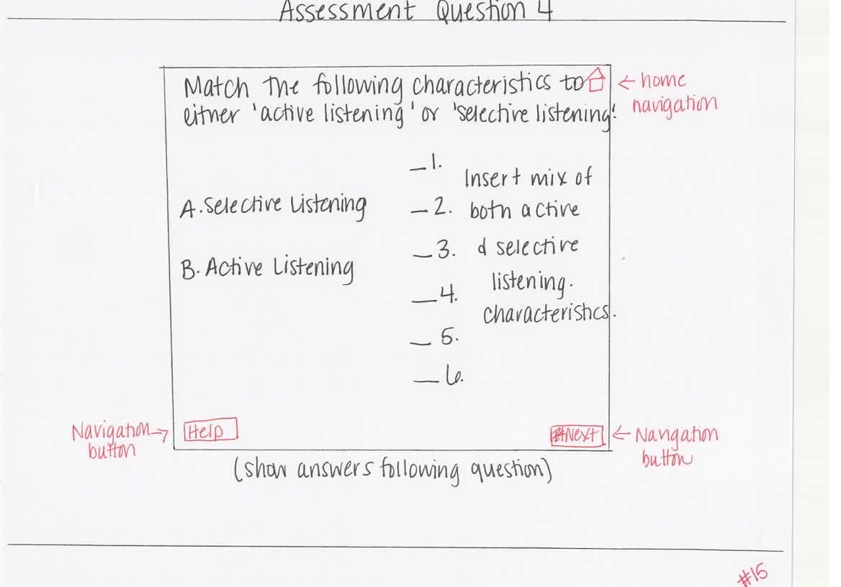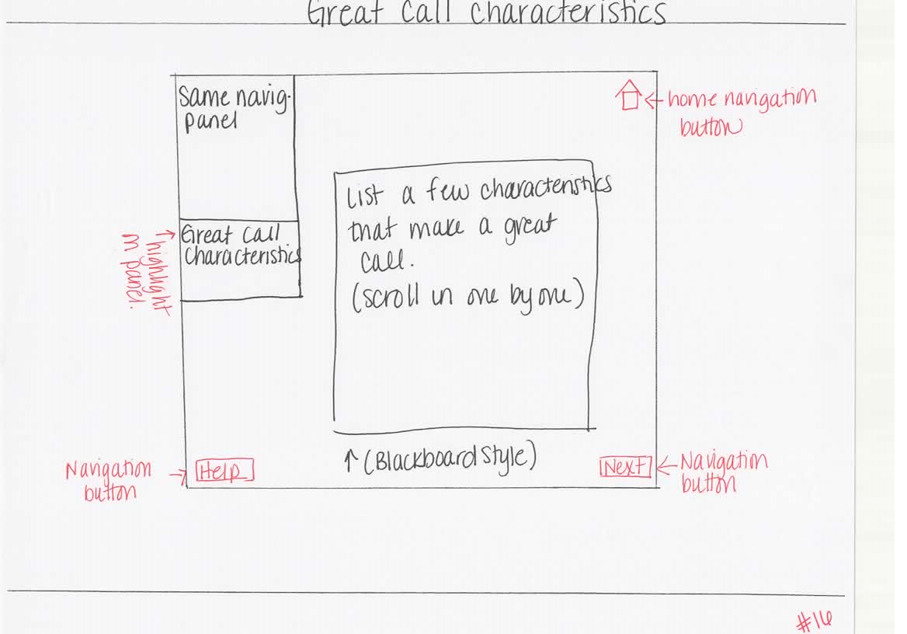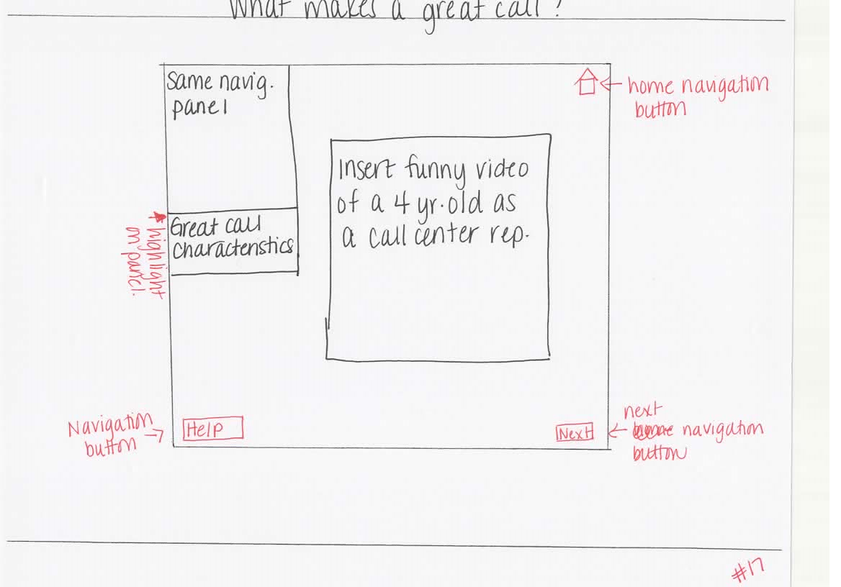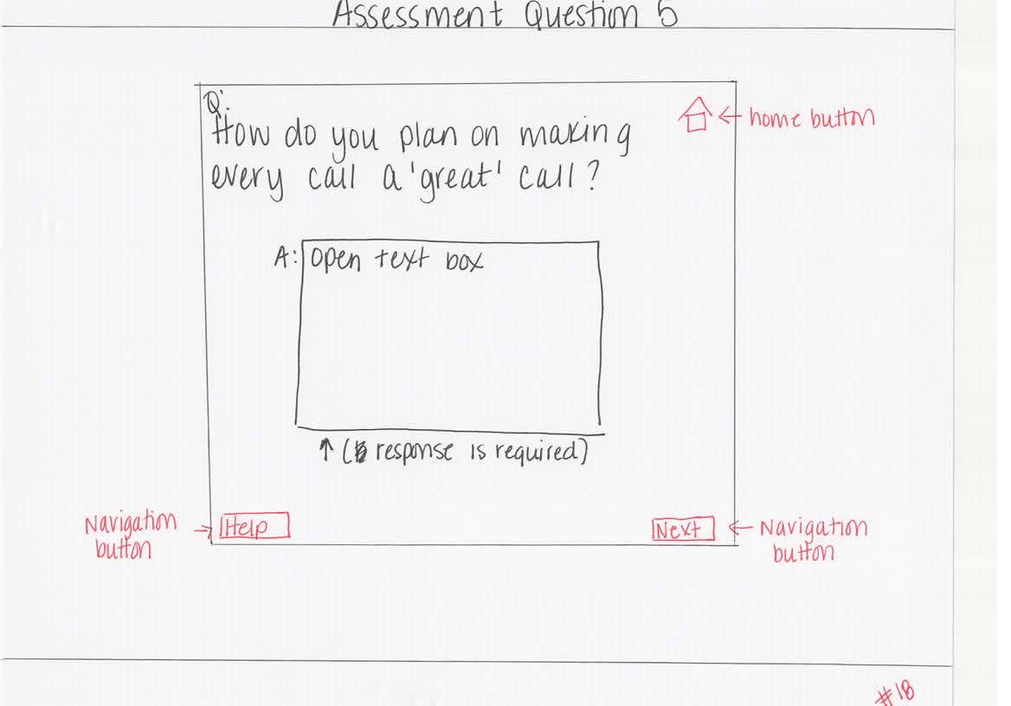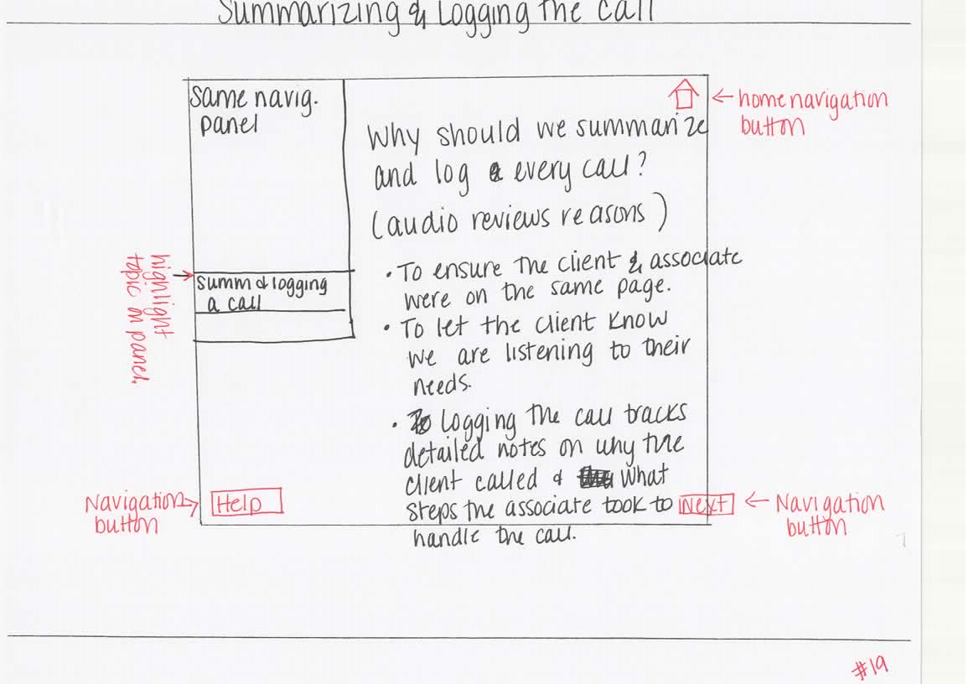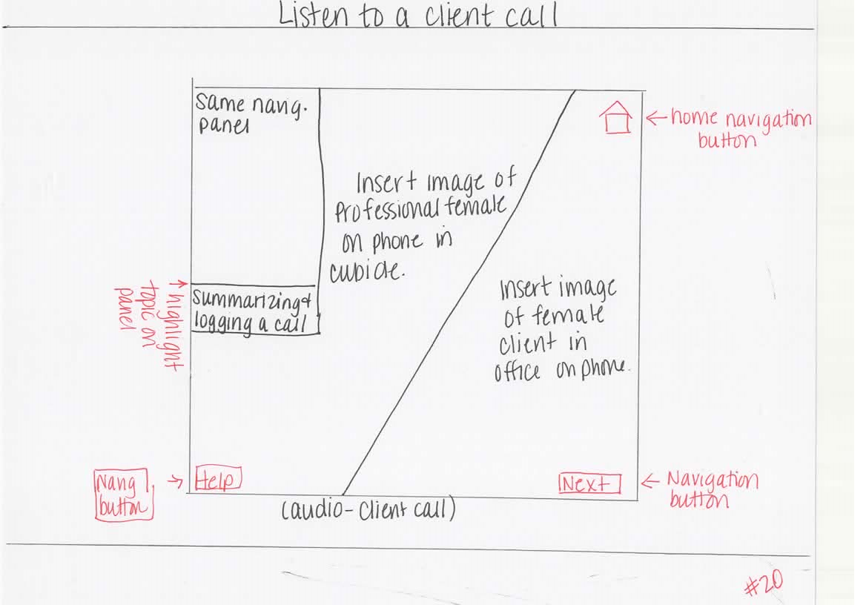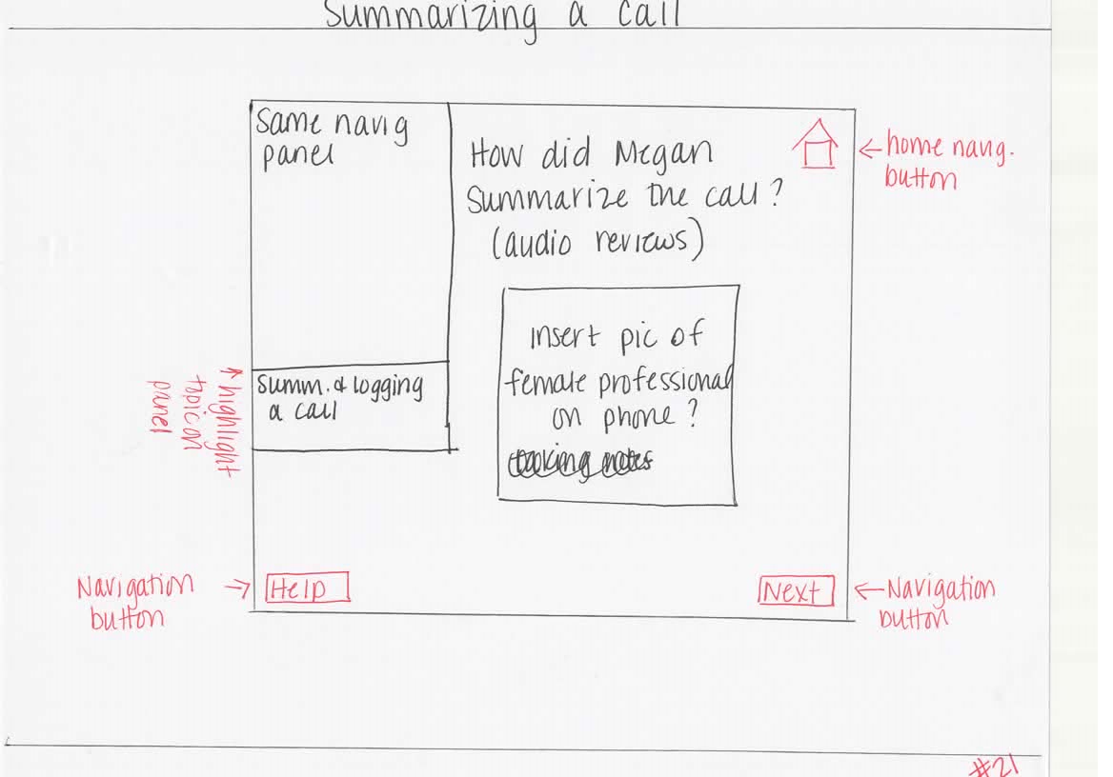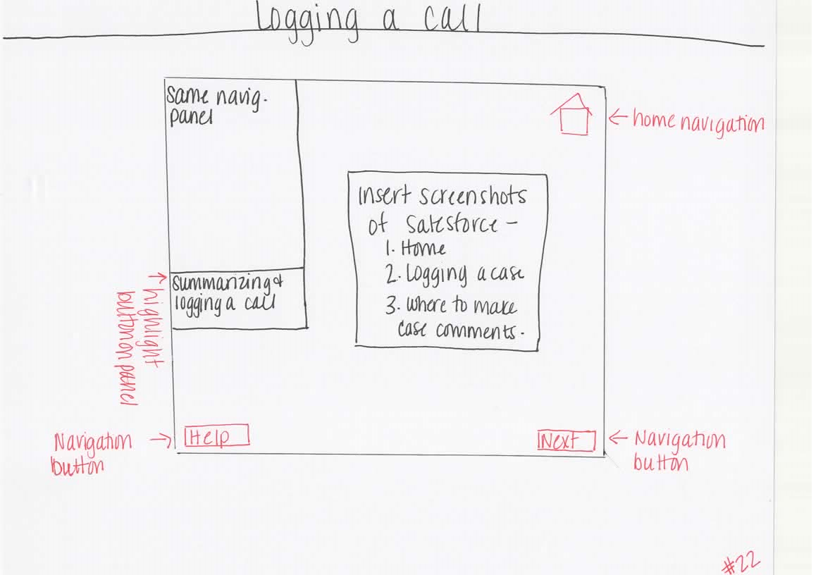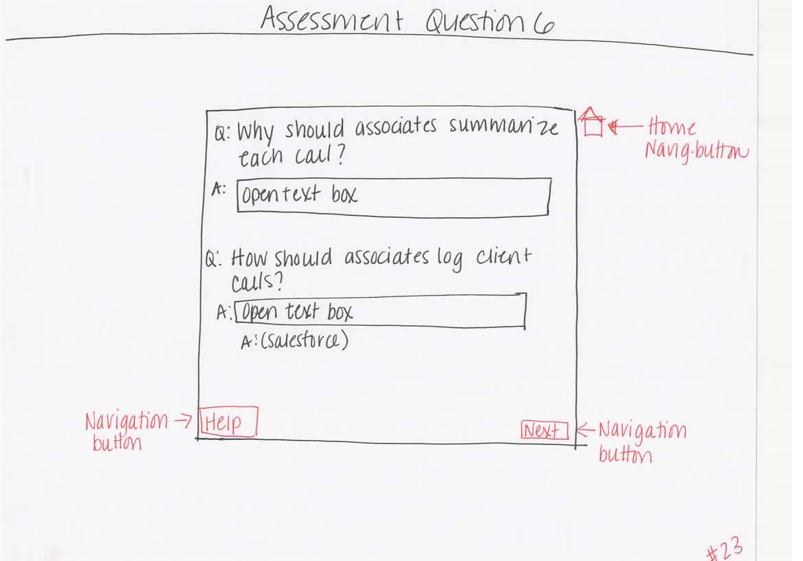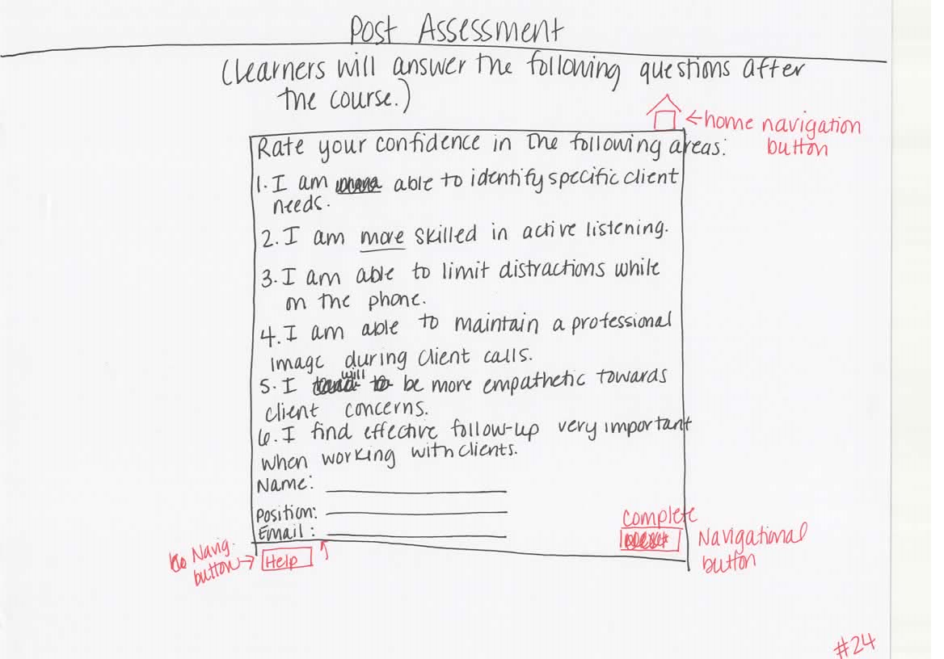
Additional Content:
#1 Welcome Screen Graphics:


#3 Learning Objectives:
- Given real-life recorded client phone interactions with a Paycor associate, learners will successfully identify specific client needs.
- Understand how to demonstrate a professional image during client phone interactions by applying at least three ways to provide remarkable service to the client.
- Given a client phone interaction, learners will understand how to limit distractions and practice active listening skills while on the phone with clients.
- Given a specific product issue, learners will understand how to incorporate confidence, empathy statements, and the benefits of summarizing each phone call.
- Learners will recognize the importance of effective follow-up and logging the client interaction.
Blackboard Design Background:

#4 Picture of Female Professional:

#5: Pictures of Client and Associate:


#7-Graphics and Text
http://www.steamfeed.com/how-to-provide-remarkable-customer-service/
3 Ways to provide remarkable service:
- Under promise, over deliver
- Keep the customer first throughout the call.
- Make the personal connection.


#8- Professional Image Video

#9- Positive and Negative Ways to provide remarkable service: (highlighted ones are the positive ones)
- Keep the client first throughout the call.
- Be quick on the call, and let the client know how busy you are.
- Speed through the information.
- Make the personal connection.
- Clearly introduce yourself, and remember the client’s name from the first introduction.
- Take a few notes, but try to remember the rest.
- Thank the client for choosing Paycor.
- Present other service add-ons if the client shares challenges Paycor could assist with.
- Tell the client you must get off the phone as you have lunch plans.
- If the client is upset, you should show empathy.
#10-Image and Reasons why we should limit distractions:

- Reminds the client we are focused on them.
- Allows us to fully understand their specific needs and reasons for calling.
- Maintains a professional image
#11- Image and distractions image





(Put X over phone, food, coffee)
#12- For game, they will put an X over the phone, coffee, cake, and other employees.


#13- Video on Active Listening- https://youtu.be/t2z9mdX1j4A
#14-What is active listening?
- Where you are making a “conscious effort” to understand the full message someone is sharing.
How can Paycor associates practice active listening?
- Be fully engaged in the phone conversation.
- Re-iterate the client’s concerns or needs.
- Stay away from interrupting the client.
#15-Active Listening and Selective Listening Characteristics.
- Selective Listening B. Active Listening
A 1.Does not remember the client’s name when they state it the first time.
B 2. Shows empathy for client after hearing concerns.
B 3. Re-iterates client’s concerns or needs.
A 4. Interrupts client to share their own thoughts.
A 5. Starts to prepare your own thoughts while the client is talking.
B 6. Shares responsive words such as “yes” and “uh huh”

#16- Great Call Characteristics
- Do something extra special for the client.
- Ask them questions to understand their needs.
- “Pretend it’s you!,” (Friedman, N., http://www.telephonedoctor.com/our_blog/ten-best-customer-service-techniques/ )
#17-What makes a great call?
Show the following video: Customer Service at it's best! (4 Year Old as Cust. Serv. Rep)
#20-Listen to a Client Call
Pictures below to be used on screen:


#21-Summarizing a call


#22- Logging a Call
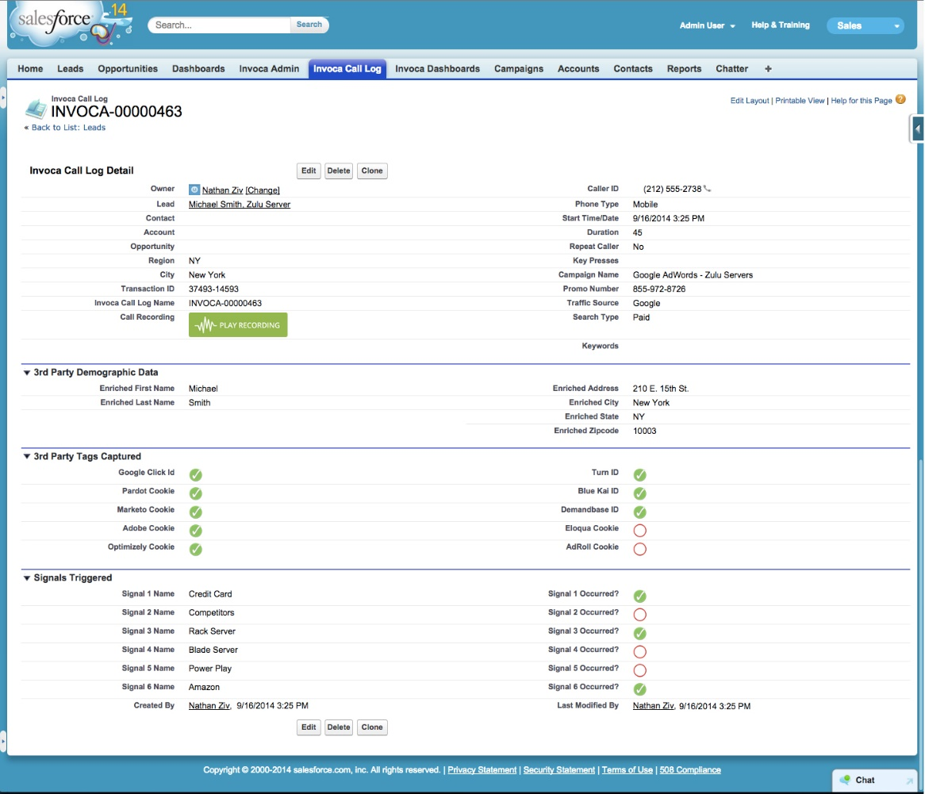

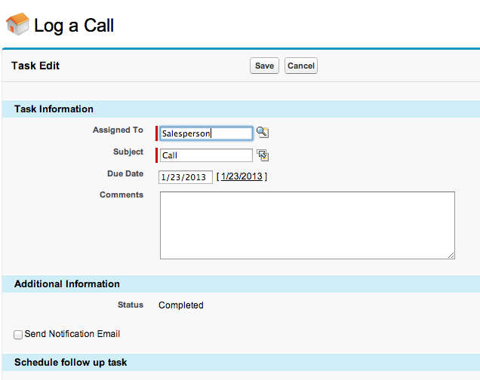

Merrill’s Five Star Instructional Design Rating

Type of Instruction: Stand along e-learning course

Stage | Criteria | Explanation
PROBLEM  Is the courseware presented in the context of real world problems? Yes, the content surrounds real-life phone interactions with current clients/issues. | Does the courseware show learners the task they will be able to do or the problem they will be able to solve as a result of completing a module or course? Yes, the course discusses how associates will be able to improve their phone skills with clients. | The course goes in detail on why Paycor associates should provide remarkable customer service through each client interaction, and how to limit distractions. It might not be a progression of problems, but the training goes in detail on how to provide remarkable service.
 | Are students engaged at the problem or task level not just the operation or action levels? Yes, these students are at the heart of this training as they will deal with the day-to-day issues clients face. Their ability to handle the phone interactions is essential to remarkable service.
 | Does the courseware involve a progression of problems rather than a single problem? Yes, in some respects. (See explanation)
RATING FOR PROBLEM STAGE:
ACTIVATION  Does the courseware attempt to activate relevant prior knowledge or experience? Yes, see explanation. | Does the courseware direct learners to recall, relate, describe, or apply knowledge from relevant  past experience that can be used as a foundation for new knowledge? Yes, see explanation. | All associates completing the course will have some background of making phone calls whether at a personal or professional level. They will be able to build upon this current knowledge with these new tips. Learners will be asked open ended questions on what makes a great call, along with a pre-post assessment of their personal phone skills.
 | Does the courseware provide relevant experience that can be used as a foundation for the new knowledge? Yes, see explanation.
 | If learners already know some of the content are they given an opportunity to demonstrate their previously acquired knowledge or skill. Yes, see explanation.
RATING FOR ACTIVATION STAGE:
DEMONSTRATION  Are the demonstrations (examples) consistent with the content being taught? Yes, see explanation. | Are the demonstrations (examples) consistent with the content being taught? Yes, see explanation.  - Examples and non-examples for concepts? Yes, see explanation.  - Demonstrations for procedures? Yes, see explanation.  - Visualizations for processes? Yes, see explanation.  - Modeling for behavior? Yes, see explanation. | The demonstrations and examples are deeply connected to each topic discussed. There are even two audio files from real Paycor employees and clients. This allows new employees to physically hear how phone calls are completed in a Paycor setting. The learners are directed to the most relevant information on making remarkable phone interactions.
Are at least some of the following learner guidance techniques employed? Yes, see explanation.
- Learners are directed to relevant information? Yes, see explanation.
- Multiple representations are used for the demonstrations? Yes, see explanation.
- Multiple demonstrations are explicitly compared? Yes, see explanation.
 | Is media relevant to the content and used to enhance learning? Yes, through multiple current videos, and audio files.
RATING FOR DEMONSTRATION STAGE:
APPLICATION  Are the application (practice) and the posttest consistent with the stated or implied objectives? Yes, see explanation. | Are the application (practice) and the posttest consistent with the stated or implied objectives? Yes, see explanation.  - Information-about practice requires learners to recall or recognize information. Yes, see explanation.  - Parts-of practice requires the learners to locate, name, and/or describe each part. Yes, see explanation.  - Kinds-of practice requires learners to identify new examples of each kind.  - How-to practice requires learners to do the procedure. Yes, see explanation.  - What-happens practice requires learners to predict a consequence of a process given conditions, or to find faulted conditions given an unexpected consequence. Yes, see explanation. | The e-learning course includes a pre-assessment and post-assessment that directly align with the learning objectives. The practice exercise requires learners to answer specific questions on each topic that was reviewed.
 | Does the courseware require learners to use new knowledge or skill to solve a varied sequence of problems and do learners receive corrective feedback on their performance? Yes, clients will receive feedback after each question.
 | In most application or practice activities, are learners able to access context sensitive help or guidance when having difficulty with the instructional materials? Is this coaching gradually diminished as the instruction progresses? Yes, there is a navigational help screen that will connect them to someone from the Paycor learning team.
RATING FOR APPLICATION STAGE:
INTEGRATION  Does the courseware provide techniques that encourage learners to integrate (transfer) the new knowledge or skill into their everyday life? Yes, see explanation. | Does the courseware provide an opportunity for learners to publicly demonstrate their new knowledge or skill? Yes, see explanation. | Learners will be working with clients on the phone soon after this training. They will be able to apply what they learned.
 | Does the courseware provide an opportunity for learners to reflect-on, discuss, and defend their new knowledge or skill? Yes, during the post assessment.
 | Does the courseware provide an opportunity for learners to create, invent, or explore new and personal ways to use their new knowledge or skill? Yes, the Paycor learning team is open to suggestions. If a new employee has an additional strategy that could be a benefit, they would be able to share this with the learning team.
RATING FOR INTEGRATION STAGE:

References
Active Listening: Hear What People are Really Saying. (n.d.). Retrieved February 12, 2016, from https://www.mindtools.com/CommSkll/ActiveListening.htm
Professional Phone Etiquette : Phone Etiquette: Speed, Volume & Articulation. (n.d.). Retrieved February 11, 2016, from https://youtu.be/PcX3jFXgPac
Ten Best Customer Service Skills and Techniques. (n.d.). Retrieved February 11, 2016, from http://www.telephonedoctor.com/our_blog/ten-best-customer-service-techniques/
The COR. (n.d.). Retrieved January 22, 2016, from https://thecor.paycor.com/groups/wowfactors
YOUNGEST CALL CENTER AGENT (4 Years Old). (n.d.). Retrieved February 11, 2016, from https://youtu.be/qZIkrm53Iyo
http://www.telephonedoctor.com/our_blog/ten-best-customer-service-techniques/

