Fakebook Project: A formal analysis of design, implementation, and evaluation

Amy Dean

J. Mason New

Amanda Pitsch

Mari Thomas

Purdue University

Table of Contents

Introduction……………………………………………………………………………………....4

Analysis………………………………………………….……………………………………….5

*Performance Analysis and Needs Assessment*…………….……………………………………5

*Instructional Goal*…………………………………………………………………………6

*Goal Analysis*…….......……………………………………………………………………7

*Subordinate Skill Analysis*…………...……………………………………………………8

*Learner Analysis*…………………………………………………………………………..9

*Context Analysis*……………………………………………………………………….....11

Design…....………………………………………………………………………………………12

*Design Evaluation Chart*………………………………………………………………...12 *Assessment Plan*………………………………………………………………………….16

*Instructional Strategy*………...…………………………………………………………….…18

*Objective Sequence and Clusters*…………………………………………………………18

*Content Presentation and Learner Participation*…..….………………………………….18

*Cluster 1*....…………………………………………………………………………..18

*Cluster 2*....…………………………………………………………………………..20

*Cluster 3*....…………………………………………………………………………..22Development………………………………………………………………………………...…...24

*Agenda*…………………………………………………………………………………….24

*Workshop materials*……………………………………………………………………….24

*Pretest*……………………………………………………………………………….24

*Internet Safety*……………………………………………………………………….24

*Fakebook Tips*………………..……………….. ……………………………………24

*Post Workshop Survey*……………………………………………………………….24

Implementation, Evaluation, Revision…………………………………………………………...24

*Implementation*……………………………………………………………………………24

*Formative Evaluation and Revision*………….……………………………………………30

Appendix A: Agenda………….………………………………………………………………....32

Appendix B: Entry Skills...……………………………………………………………………....34

Appendix C: Pre-Test…………………………………………………………………………....35

Appendix D: Internet Safety…..…………………………………………………………………37

Appendix E: Resource Guide………………………………………………………………....….38

Appendix F: Rubric....………………………………………………………………………...….40

Appendix G: Post-Test………………………………………………………………………..….42

References…………………………………………………………………………………….….43

Introduction

The intended purpose of this instructional workshop is to teach learners (i.e., sixth grade students) about the educational usage of the social media site, Fakebook. The sixth grade team at Landon Middle School made the decision to instruct learners about the Fakebook site in response to a recent school requirement of one project-based learning activity per course per year and the fact that this cohort of learners will also be the first class to be issued individual Chromebooks. Although the learners will be exposed to an online research experience that fulfills a project-based assignment requirement and aligns with core middle school standards ([Indiana Department of Education Academic Standards](http://www.doe.in.gov/sites/default/files/standards/enla/k-5_ela_draft-7-7-14-et.pdf)), the activity will also address a learner motivation concerns and the educational imperative to teach young people about the appropriate usage of educational technologies for instructional purposes.

According to Edudemic (2015), over 90% of young learners, ages 12-17, use the internet for personal reasons. As early as 2003, Murphy, DePasquale, and McNamara (2003) found that educators and learners are very proficient and adept at using technology in their personal lives, yet less comfortable and familiar with the effective and appropriate usage in the educational environment. Ertmer and Ottenbreit-Leftwich (2009), suggest that even as recently as 2009, educators and learners were still reporting minimal gains in the appropriate usage of educational technologies in the classroom environment. Thus, the previous findings align with Youngbauer’s (2013) recent claim that providing learners with educational learning experiences that enhance social media literacy is one of the most critical issues facing 21st Century educators.

With such claims about the gap between personal and educational usage, the value of the integration of educational technologies in the classroom, and the requirement of project-based learning experiences aligned with stated core standards, it seems appropriate to offer a specific training session on the educational value and appropriate usage of Fakebook in the classroom.

Performance Analysis and Needs Assessment

In an attempt to gain a better understanding regarding learner internet usage, social media exposure, and engagement (i.e., learner motivation, learner relevance), the sixth grade teachers (i.e., Social Studies, Language Arts, and Math) determined that a pre-assessment of their sixth grade learners was necessary. Given that the school was on summer break, the teachers selected a representative sample of the sixth grade class to pre-assess in efforts to gain a relatively accurate portrait of learner skills. The sample was assessed in terms of their internet usage, social media familiarity, and learner engagement variables.

Upon the conclusion of the learner assessment (i.e., 6 out of 24 or 24%), the sixth grade teachers discovered that the representative sample demonstrated a strong knowledge of technology (i.e., 85% of the sample use internet for personal usage, 88% find the internet easy to navigate, and 70% use the internet daily), but needed more information about social media usage (i.e., 10% accessed a social media platform). And, although the six learners demonstrated an array of knowledge and skills necessary to successfully navigate the Fakebook site and create a profile page, individual responses to the questions linked to their Social Studies research project indicated that the learners did not understand the educational value.

The results of this pre-assessment suggested findings similar to the results gathered by the International Society for Technology in Education (2015) (www.iste.org). Specifically, the ISTE (2015) findings suggest that 21st Century learners demonstrate limited personal proficiencies in locating, analyzing, and evaluating information gathered from various technological resources and therefore need educational training and support (www.iste.org). Furthermore, ISTE (2015) contends that learners must be coached to effectively share thoughts and ideas with a variety of viewers within an array of digital media arenas (www.iste.org).

Though the group of *tryout learners* was a small, the workshop team felt confident that the findings from this representative sample were valid and reliable. Therefore, after analyzing the pre-assessment data, the workshop team agreed the sixth grade learners have the necessary skills to successfully complete this online task. Although the team determined that learners have the skills to complete this task, they also agreed that the learners would benefit from additional instructional opportunities to become proficient with the array of required skills to independently complete this Fakebook activity. Furthermore, the team concluded that the sixth grade learners needed greater clarity on the educational importance of this Social Studies problem-based learning experience.

Instructional Goal

*To create a comprehensive Fakebook profile for a self-selected historical character.*

Goal Analysis

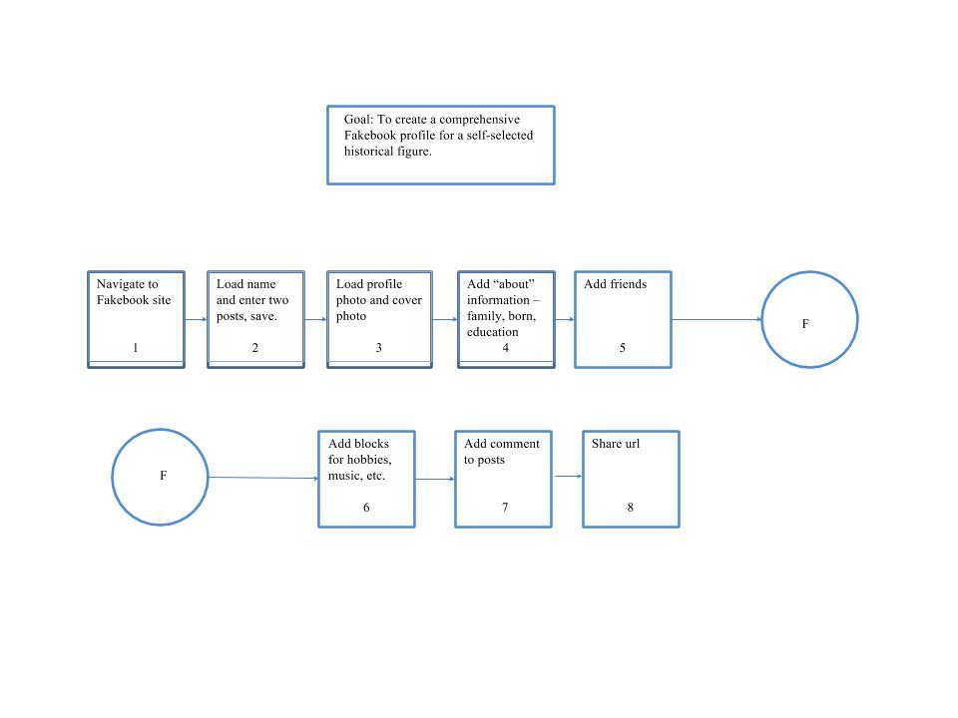

Subordinate Skill Analysis

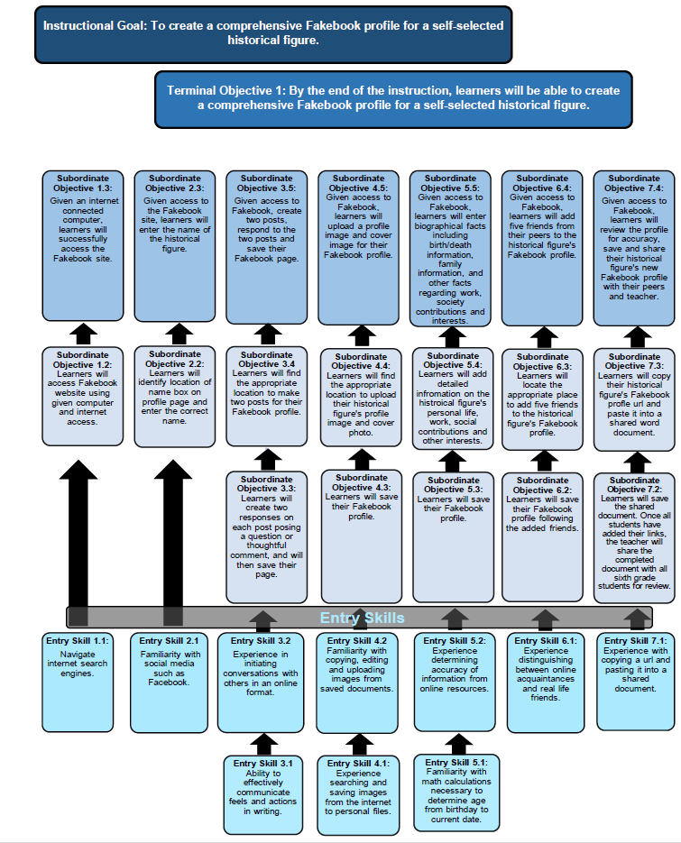

Learner Analysis

The target population is a sixth grade class at Landon Middle School. The class consists of 29 students; 14 males and 15 females. All learners fall between the ages of 11-13. This sixth grade cohort is the first 1:1 Chromebook class for the school. All learners have access to an internet ready Chromebook at home and school. Additionally, 40% of the students have smart phones and use messaging and email applications.

*Motivation*. The learners involved in this workshop have completed a wide array of instructional tasks related to reading and research activities. Although all prior assignments have been paper and pencil tasks, recently the sixth grade team decided to engage in an online research project that integrated educational technologies and alternative assessments. In preparation for this new educational experience, the learners spent one class week researching a self-selected historical figure so as to identify personal qualities and characteristics, family connections, friends, and interests. The rationale for the research activity was to promote learner engagement in Social Studies through the integration of a project-based learning experience. According to Brooks (2014), middle school learners demonstrate a loss of interest in history due to lack of personal relevance, general decline in motivation for learning in middle school, and confusion about developmental needs and teacher expectations.

When the group of *tryout learners* was offered the opportunity to experiment with the Fakebook site, all learners accepted the challenge. Thus, the eagerness of the *tryout learners* suggested that individuals in this sixth grade class may be interested in computer-based research and reading experiences. Additionally, sample cohort appeared interested in attempting computer-related activities that align with school requirements, specifically a Social Studies project-based learning assignment.

*Ability*. According to the summary data from the previous state mandated *No Child Left Behind* test, the I-Step, the cohort of sixth grade learners are at or above average in comparison to same-aged peers who completed the same state assessment. Although the majority of the learners do not have diagnosed disabilities, one young man in the class is dyslexic and another young woman has a specific learning disability in the area of language arts. Both learners with disabilities have access to a learning support professional for class assignments.

*Learning Preferences.* Prior to the launch of this instructional workshop, the sixth grade class completed an interest inventory to assess learning preferences. The results of the preference inventories from this cohort indicated the learners prefer direct, teacher-led instruction, with occasional opportunities for choice and independence. Given the results from the interest inventories and the recent request from the school leadership team to include a project-based learning experience, the workshop instructors must be mindful of both learner preferences and project-based learning expectations and practices.

*Attitudes.* This group of learners have been exposed to supplemental instructional workshops in the past (i.e., Think Smart, Be Safe!) and have demonstrated kind, courteous and compliant behavior. Additionally, this class was invited to the local area Public Park District Office for a hands-on instructional workshop about trees. The post-trip teacher feedback was positive and indicative of the same type of compliant, courteous, and engaged behavior as observed during in-school supplemental learning sessions. Based upon these two experiences, the workshop leaders are confident the learners will be open to this instructional workshop about Fakebook.

Context Analysis

The instructional workshop will be presented to the group of sixth grade learners in their homeroom classroom. The Social Studies teacher, media specialist, and technology teacher will be present for the instructional workshop. Given that all of the learners have been given a Chromebook for school, each learner will be at his or her respective seat with his or her Chromebook for this instructional workshop. The instructional leaders will have Chromebooks, as well. One primary Chromebook will be connected to the projector so that the learners will be able to see that actual activity that the leader is engaged in throughout the workshop. The instructional leaders have presented other activities to the cohort in the past, so their presence is not atypical.

The sixth grade Social Studies teacher, along with the Language Arts teacher, will assign the learners with a follow-up Fakebook assignment shortly after the instructional workshop has concluded. The learners will be asked to add and update their Fakebook profile as part of the follow-up assignment. An informational handout (see Appendix E) will be provided to the learners for the extension assignment to ensure that they have the necessary information to successfully complete the required assignment. The class will be required to use their Chromebook and save their Fakebook URL in their assigned Google Classroom.

A primary limitation of this workshop is the instructional leaders will not have access to on-call technical support in case of issues with the computers. This may impose a limitation if students experience hardware, software or connectivity issues on multiple computers.

Design

*Design Evaluation Chart*.

|  |  |  |
| --- | --- | --- |
| **Main Instructional Goal** | **Terminal Objective** | **Test Item** |
| Create a detailed Fakebook profile for a historical figure, selected by the individual learner. | By the end of the lesson, learners will be able to create a detailed Fakebook profile for a self-selected historical figure. | Through provided instruction, learners will demonstrate the ability to create a comprehensive Fakebook profile page for a self-selected historical figure. |
| Main Step in Instructional Goal | Objective | Test Item |
| 1. Learners will access the Fakebook site utilizing given computer. | Through learners receiving an internet connected computer, they will be able to connect to the internet and access the given website for the project:<http://www.classtools.net/FB/home-page>. | Through the utilization of a given computer, and internet access, learners will demonstrate the ability to access the given Fakebook profile web address. |
| Subordinate Skills | Objective | Test Item |
| 1.1 Learners will access the internet and type the appropriate Fakebook web address into the url bar at the top of the page. | Through learners receiving the appropriate url, and an internet capable computer device, learners will be able to access the Fakebook profile website:<http://www.classtools.net/FB/home-page>. | Learners will show the media specialist their ability to accurately access the internet from the given computer and type in the Fakebook website url. |
| Main Step in Instructional Goal | Objective | Test Item |
| 2. Learners will identify specific areas where biographical information will be entered on the selected historical figure, including the name of the figure. | Through the internet and the Fakebook website, learners will be able to locate the appropriate areas for the historical figure’s information including the name of the figure. | Learners will locate the appropriate areas for biographical information when asked by the media specialist. |
| Subordinate Skills | Objective | Test Item |
| 2.1 Learners will enter the correct name of their historical figure. | Through the internet and the Fakebook website, learners will correctly enter the name of their selected historical figure on the Fakebook profile website. | Learners will demonstrate this skill by locating the appropriate field for the historical figure’s name and correctly typing in the name. |
| Main Step in Instructional Goal | Objective | Test Item |
| 3. Learners will make two posts and create two responses to each post. | Through internet access and the Fakebook website, learners will successfully enter two posts and two responses to their historical figure profile. | Through the demonstration of creating and responding for two posts, learners will demonstrate their known abilities to the media specialist. |
| Subordinate Skills | Objective | Test Item |
| 3.1 Learners will find the appropriate location to make the two posts for their Fakebook profile. | Learners will be able to create two posts on their historical figure through internet access and the Fakebook website. | By demonstrating the ability to identify the location of where to make Fakebook posts will show the media specialist the learner is able to continue the lesson. |
| 3.2 Learners will create two responses on each post posing a question or thoughtful comment, and will then save their page. | Learners will be able to provide two responses to the original posts through internet access and will follow with saving the Fakebook profile page. | Learners will demonstrate this step by adding two responses on each of the two previously made posts. |
| 3.3 Learners will save their unique Fakebook page. | After learners accurately enter two posts for their historical figure, s/he will locally save the profile page. | Learners will give verbal confirmation to the instructor that their unique Fakebook has been saved locally. |
| Main Step in Instructional Goal | Objective | Test Item |
| 4. Learners will upload a profile image and cover image for their Fakebook profile. | Learners will upload a researched profile image and cover photo for their historical figure utilizing an internet search engine, the Fakebook website, and a given thumb drive. | Learners will demonstrate this step for the media specialist by successfully locating and uploading the historical figure’s profile picture and cover photo. |
| Subordinate Skills | Objective | Test Item |
| 4.1 Learners will find the appropriate location to upload their historical figure’s profile image and cover photo. | Through access to the internet, learners will be able to successfully search, identify, and upload a profile picture and cover photo on their historical figure. | Learners will demonstrate the ability to upload the profile and image by navigating the Fakebook website. |
| 4.2 Learners will save their Fakebook profile. | Learners will be able to save the uploaded profile picture and cover photo once properly added to their historical figure’s site. | Learners will demonstrate this by saving their historical figure’s Fakebook profile, and then seeing the information once the website is refreshed. |
| Main Step in Instructional Goal | Objective | Test Item |
| 5. Learners will enter biographical facts including birth/death information, family information, and other facts regarding work, society contributions and interests. | Through the Fakebook website, and internet search engines, learners will be able to research and locate detailed information on their historical figure including facts on their personal life, family, and other contributions. | Learners will describe the various personal data discovered and added to the Fakebook profile. |
| Subordinate Skills | Objective | Test Item |
| 5.1 Learners will add detailed information on the historical figure’s personal life, work, social contributions and other interests. | Though appropriate internet search engines, learners will be able to add detailed personal information on their self-selected historical figure. | Learners will demonstrate the ability to add detailed information by sharing what information was added, where they researched facts, and the ease of adding new information to the Fakebook website. |
| 5.2 Learners will save their Fakebook profile. | Once learners have added the needed personal information, learners will be able to save the new information added to the Fakebook profile. | Learners will demonstrate the ability to save their page by sharing the location of where to save and then refreshing the Fakebook profile to see the newly added information. |
| Main Step in Instructional Goal | Objective | Test Item |
| 6. Learners will add five friends from their peers to the historical figure’s Fakebook profile. | Learners will be able to add five new friends to the Fakebook’s historical profile utilizing the Fakebook website and internet access. | Given access to the Fakebook profile, learners will search and select five new friends to be added to the historical figure’s Fakebook profile page. |
| Subordinate Skills | Objective | Test Item |
| 6.1 Learners will locate the appropriate place to add five friends to the historical figure’s Fakebook profile. | Learners will be able to add the five new friends through given internet access and locating the Fakebook website. | Learners will demonstrate the ability to add five friends by sharing with their partner which friends they added and why. |
| 6.2 Learners will save their Fakebook profile following the added friends. | Learners will save the updated Fakebook profile following the addition of five new friends. | Learners will save the historical figure’s page and then refresh to ensure the profile was properly saved. |
| Main Step in Instructional Goal | Objective | Test Item |
| 7. Learners review the profile for accuracy, save and share their historical figure’s new Fakebook profile with their peers and teacher. | Learners will add their historical figure’s url to a shared document. This document will then be shared with all students and teachers in the sixth grade. | Learners will swap seats with their partner for a peer review which will provide an opportunity for improved accuracy. |
| Subordinate Skills | Objective | Test Item |
| 7.1 Learners will copy their historical figure’s Fakebook profile url and paste it into a shared word document. | Through internet access, and a shared document, learners will be able to add their unique Fakebook profile’s url to the document. | This will be demonstrated through the teacher verifying the learner has added the correct url to the shared word document. |
| 7.2 Learners will save the shared document. Once all students have added their links, the teacher will share the completed document with all sixth grade students for review. | Through the online shared document, the teacher will be able to share the finalized version with students. | The teacher will confirm the completion of students adding their unique link to the shared document through visually verifying before forwarding the completed document to all other students and sixth grade teachers. |

Assessment Plan

*Entry skills assessment.* All students havecompleted a computer skills class, as well as conducted research in social studies and other subject matter classes. However, passing these courses and completing such activities does not indicate confidence or proficiency. An entry skills pre-assessment (see Appendix B) has been developed and involves demonstration and explanation activities. The school Computer teacher will be the administrator of this pre-assessment and has been provided a skill rubric to use to assess learner proficiency in the aforementioned skills. This required pre-assessment will occur during one technology class period. As per the agreement between the workshop instructors and the Computer teacher, the learners will be allocated one assessment session to demonstrate proficiency in successfully accessing a specific website when given the necessary URL information, saving a word document to their Google classroom personal folder, sharing the saved word document in the Google classroom blog space, uploading an image to a blank word document, and responding to a written prompt about internet safety. According to Dick, Carey, and Carey (2015), alternative assessments are a good option for assessing learner performance. Additionally, Dick, Carey, and Carey (2015) explain that the primary task of the instructor is to create solid questions to guide behavior and an aligned rubric to assess performance. The instructors of the workshops have adhered to these suggestions and created both guiding questions and assessment rubric.

*Pretest.* The sixth grade students will complete a pretest (see Appendix C) using hands-

on activity on a given computer with internet access. The students will be asked to demonstrate their ability to:

1. Login to a computer

2. Access the internet and given website(s).

3. Copy and paste a link into a word document.

4. Research a picture of a given object and then save that image to the given flash drive. The student will then upload the image onto a selected platform.

5. Answer a few questions on internet safety.

*Practice test.* The activities completed during the workshop will serve as the practice test (see Appendix F). As the learners complete each objective, s/he will demonstrate understanding and proficiency through the addition of each required Fakebook element. For example, once a learner completes a post, s/he has now practiced that event and thus can successfully complete additional posts as the workshop requires. If the learner does not successfully achieve each objective, additional support will be provided. The workshop is designed to enable learners to revisit the task until successfully completed.

*Posttest.* The final posttest (see Appendix G) is completion of the Fakebook profile, saving it to Google classroom, and sharing it with the teacher. As the learner works through the objectives, s/he is simultaneously completing the page and building towards the posttest. Each learner will add additional information to create a complete picture of the historical figure including family members, friends, activities, and posts related to certain events. Since this workshop fits into a larger Social Studies unit, subsequent posttests will involve using the educational social media resource from this workshop in other activities, such as presentations to the teacher and class about the learner’s chosen historical figure.

Instructional Strategy

*Objective Sequence and Cluster.*

|  |  |  |
| --- | --- | --- |
| **1** | **2** | **3** |
| 1.1 | 2.1 | 7.1 |
| 1 | 2 | 7.2 |
|  | 3.1 | 7 |
|  | 3.2 |  |
|  | 3.3 |  |
|  | 3 |  |
|  | 4.1 |  |
|  | 4.2 |  |
|  | 4 |  |
|  | 5.1 |  |
|  | 5.2 |  |
|  | 5 |  |
|  | 6.1 |  |
|  | 6.2 |  |
|  | 6 |  |

*Content Presentation and Learner Participation.*

Cluster 1: Access and overview.

*Objectives*

1.1 Through learners receiving the appropriate URL, and an internet capable computer device, learners will be able to access the Fakebook profile website:<http://www.classtools.net/FB/home-page>.

*Content Presentation*

*Content.* Introduce learners to a social media platform, Fakebook. Instructor will use examples of pictures going viral on Facebook and other materials (see Appendix D) about social media safety to hold a full class discussion of security concerns with social media. Topics to be covered include lack of privacy (e.g. posting you will be gone on vacation, therefore, inviting a burglar into your home), posts are forever (i.e., the reality that you can never really delete what you post), internet predation of others, scams in social media, and other relevant topics. Conversation will then turn to benefits of social media. Topics may include staying in touch with long distance friends and family, the joy of interacting with friends in community events, easy sharing of photos, and keeping abreast of upcoming events. At completion of discussion, instructor will demonstrate how to navigate to Fakebook site.

*Example.* Examples of viral photos, stories of social media security risks, samples of existing Fakebook pages.

*Student Grouping and Media Selection.* Learners will be in table groups of six, the existing manner by which their homeroom is set up. The instructional content, including Fakebook site and specific URL, will be displayed on the classroom Smartboard.

*Student Participation*

*Practice Items.* Students will participate in whole class discussion regarding social media use and safety concerns. When done, students will navigate to the Fakebook site on their individual Chromebooks.

*Feedback:*Student participation in the group discussion, successful navigation to Fakebook site.

*Student Grouping and Media Selection:*This cluster will be performed as a whole class discussion with the instructor displaying applicable media on a projector and screen for all participants to see. Students will be asked to provide both benefits and risks for the group conversation.

Cluster 2: Insert information.

*Objectives*

2.1 Through the internet and the Fakebook website, learners will correctly enter the name of their selected historical figure on the Fakebook profile website.

3.1 Learners will be able to create two posts on their historical figure through internet access and the Fakebook website.

3.2 Learners will be able to provide two responses to the original posts through internet access and will follow with saving the Fakebook profile page.

3.3 After learners accurately enter two posts for their historical figure, s/he will locally save the profile page.

4.1 Through access to the internet, learners will be able to successfully search, identify, and upload a profile picture and cover photo on their historical figure.

4.2 Learners will be able to save the uploaded profile picture and cover photo once properly added to their historical figure’s site.

5.1 Though appropriate internet search engines, learners will be able to add detailed personal information on their self-selected historical figure.

5.2 Once learners have added the needed personal information, learners will be able to save the new information added to the Fakebook profile.

6.1 Learners will be able to add the five new friends through given internet access and locating the Fakebook website.

6.2 Learners will save the updated Fakebook profile following the addition of five new friends.

*Content Presentation*

*Content.* Instruct learners on how and where to enter personal information to their unique Fakebook page. The content to be inserted includes name, posts, image, biographical information, friends, and hobbies.

*Example.* Instructor demonstrates entering the information of a chosen historical figure. Instructor shows one example of entering information and displaying a photo image, but then allows for students to practice the additional steps. Instructor displays each element of the workshop in a progression, as described in the Performance Objectives and Design Evaluation Chart.

*Student Grouping and Media Selection.* Learners will be in table groups of six, the existing manner by which their homeroom is set up. The instructional content, including Fakebook site and input options, will be displayed on the classroom Smartboard.

*Student Participation*

*Practice Items.* Learners will individually input requested information into their unique Fakebook profile. Between each individual input (i.e., name, post, image, biographical information, friends, and hobbies), the workshop instructor will ask the learners to pair up with a neighbor and show her/him the completed work.

*Feedback.* The workshop instructor will walk around the classroom and monitor student access and peer sharing using the practice test rubric (see Appendix F).

*Student Grouping and Media Selection.* Learners will work individually on the Fakebook input tasks; learners will be in pairs for the pair-sharing of their Fakebook work. Learners will be given an observation rubric to follow and mark during the partner-sharing activities.

Cluster 3: Save and Share.

*Objectives*

7.1 Through internet access, and a shared document, learners will be able to add their unique Fakebook profile’s url to the document.

7.2 Through the online shared document, the teacher will be able to share the finalized version with students.

*Content Presentation*

*Content.* Instruct learners on how to save the unique Fakebook URL to a word document to be stored in their Google classroom personal folder. The content will specifically address copying and saving the URL to a new word document and uploading the new word document to their personal folder within their Google classroom.

*Example.* Invite learners to open a blank word document. Once a blank document has been opened, request that the learners copy and paste their unique URL to the blank word document. Once the URL pasted to the document, instruct the learners to save the word document using the following saving configuration: student name historical figure. Once the learners have saved their word document, request that they save the new document in their personal folder within Google classroom. Instruct learners to post the document link in the Google classroom blog.

*Student Grouping and Media Selection.* Learners will be in table groups of six, the existing manner by which their homeroom is set up. The instructional content, including Fakebook site, blank word document, and Google classroom will be displayed on the classroom Smartboard.

*Student Participation*

*Practice Items.* Learners will individually work on saving their unique Fakebook profile URL to a word document with their Google classroom folder and posting the link to their classroom blog. At the completion of their individual input (i.e., save URL to word, save word to folder, post link to word at blog), the workshop instructor will ask the learners to pair up with a neighbor and show her/him his Fakebook and Google classroom work.

*Feedback.* The workshop instructor will walk around the classroom and monitor student work and peer sharing using the practice test rubric.

*Student Grouping and Media Selection.* Learners will work individually on the Fakebook URL saving tasks; learners will be in pairs for the pair-sharing of their Fakebook and Google classroom work. Learners will be given an observation rubric to follow and mark during the partner-sharing activities.

Development

*Agenda.*

See Appendix A.

*Workshop materials*.

Entry Skills Pre-assessment. See Appendix B.

Pretest. See Appendix C.

Internet safety. See Appendix D.

Fakebook Resource Guide. See Appendix E.

The purpose of this tool is to provide learners with an informational resource to reference throughout the workshop and for future profile activities.

Fakebook rubric. See Appendix F.

Post-workshop survey. Appendix G.

Implementation, Evaluation, Revision

*Implementation*. During the second full week of school at Landon Middle School, sixth grade learners participated in the aforementioned Fakebook workshop. The purpose of the workshop was to teach learners (i.e., sixth grade students) about the usage of the educational social media site, Fakebook. The learners had been informed about the workshop, completed an entry skills pre-assessment in computer class (see Appendix B), and conducted their Social Studies research work related to their self-selected historical figure.

The total class of 24 learners participated in the 60-minute workshop. The design of the workshop followed the previously referenced agenda (see Appendix A). The time allocated for the various activities was appropriate and enabled learners to successfully complete the requested activities. The learner preference survey, entry skills assessment, and workshop pre-assessment provided the workshop instructor with essential knowledge about learner motivation, prior knowledge, and level of readiness. Thus, the instructor rearranged the table groups of six to ensure balanced and complementary partners for the pair-share activities.

The Social Studies and Computer teachers observed the complete workshop. Throughout the workshop, the teacher observers watched and grinned as the 24 learners demonstrated attentive behaviors, successful completion of the Fakebook profile activities, and supportive and effective peer collaboration.

*Assessment.* All 24 learners successfully completed the required tasks and will be invited to share their completed Fakebook profiles during an upcoming Social Studies class. Below are two student examples that demonstrate learner success. You will notice that these two learners went above and beyond the basic requirements and embedded videos within their posts. These two examples are provided to showcase the differentiation that occurred when the learners needed additional learning opportunities during the workshop.

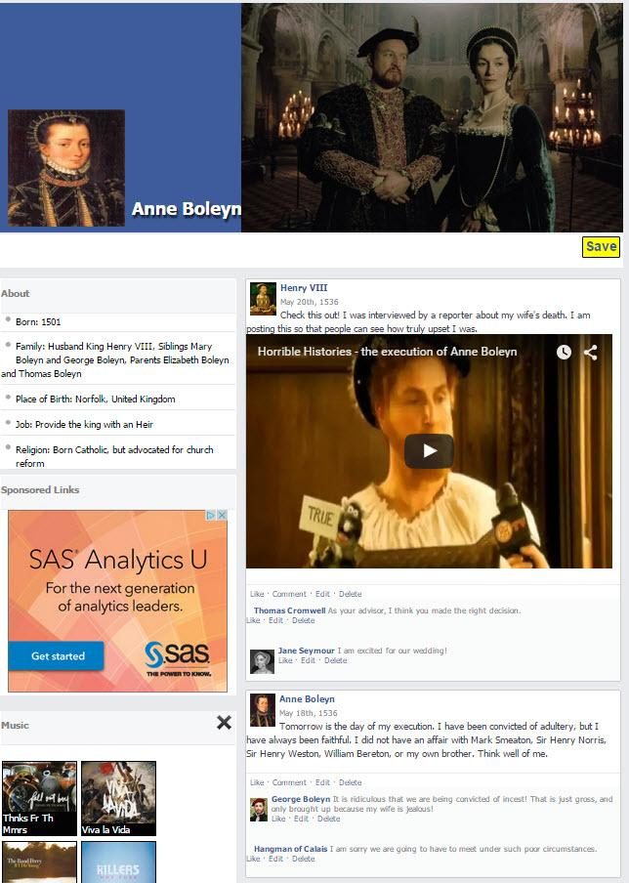

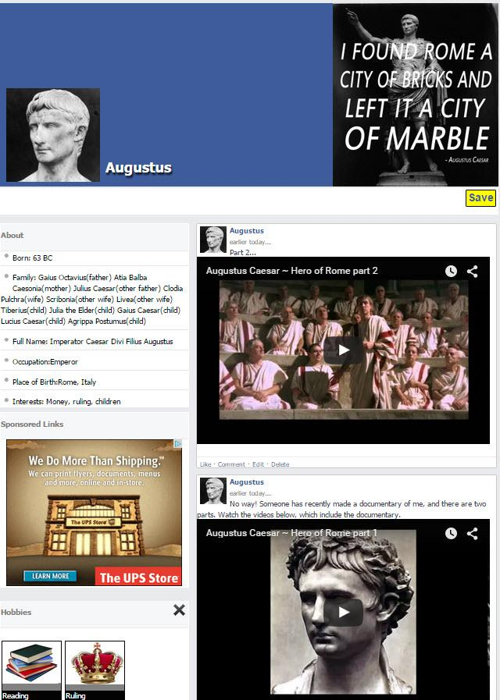

Although the learners demonstrated some initial challenges on the pre-assessment, the guided instruction, resource handout, and peer support, enabled all level learners to rise to this online, project-based challenge. One unexpected distraction was learner chatter about existing personal Facebook profiles. Though not completely shocking, the reality of this situation is that this sixth grade learners are not old enough to set-up their own Facebook profile. Such information gathered has been shared with the school principal as it is inappropriate and against school policy.

The Language Arts teacher was supportive of this project-based online work and challenged her learners to create a Fakebook profile for a favorite character from *The Lion, the witch and the wardrobe*. Below are two examples of completed Language Arts Fakebook profiles.

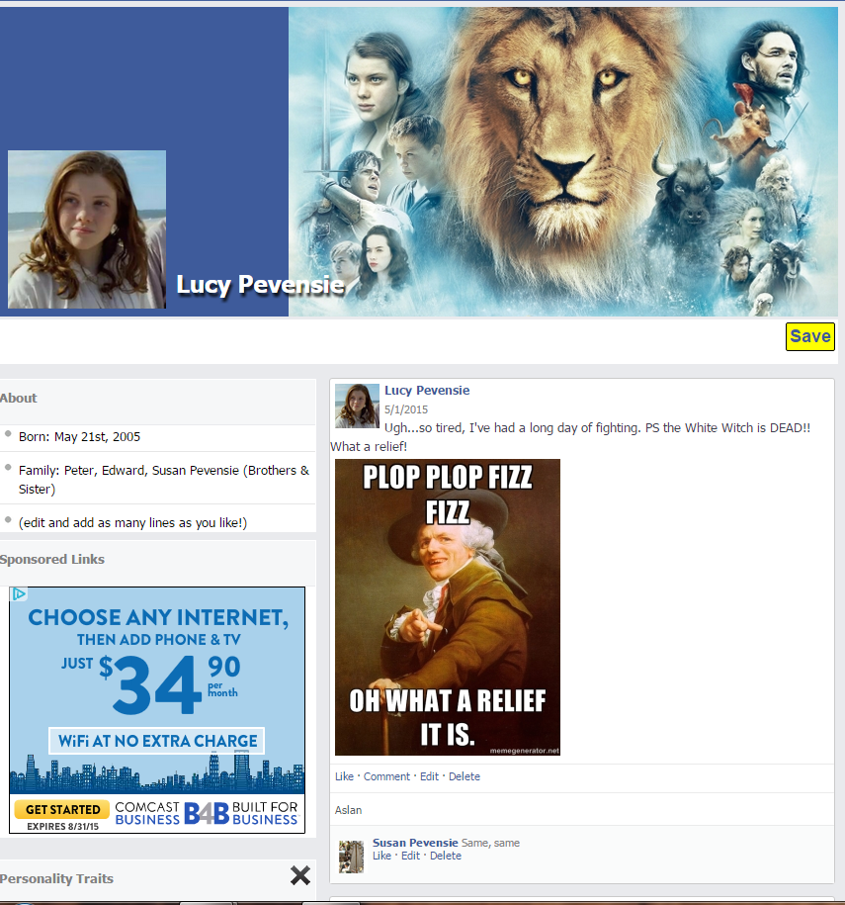

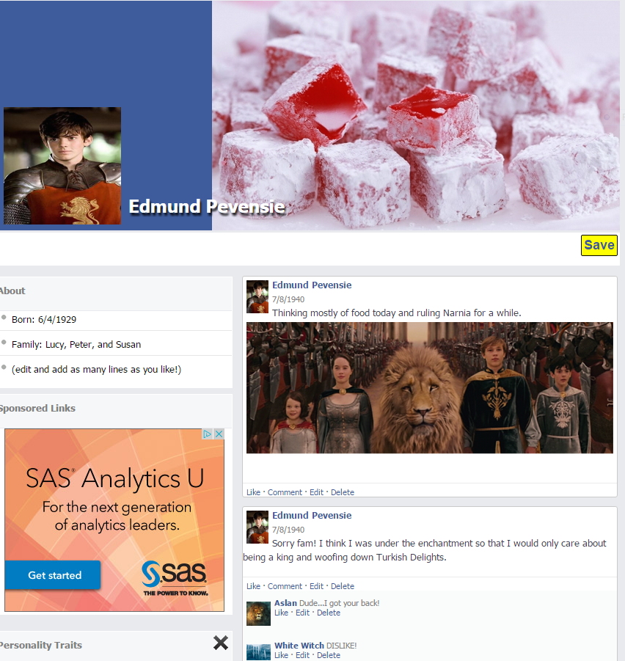

*Formative evaluation*. In reflecting upon the actual workshop, the instructors discovered that the multiple pre-assessments were repetitive and could have been consolidated. The learner entry skills assessment could have been enough. The pre-assessment at the start of the workshop was not necessary. The online safety handout, the guided instruction projected on the Smartboard, and the Fakebook resource were effective in guiding the learners through this familiar, yet minimally challenging, online activity. One suggested revision is to use the elements of the pre-assessment throughout the lesson, versus using it as a standalone pre-assessment at the start. Specifically, the pre-assessment questions could serve as the entry prompt for the related Fakebook profile activity being presented during that portion of the workshop. According to Dick, Carey and Carey (2015), assessments should provide designers and instructors with data to make changes in instruction so that the activity or lesson is more effective and addresses learner needs. The three aforementioned assessments actually provided unessential information that did not help to improve instruction and thus should be adjusted to serve as concept entry prompts.

Appendix A

Agenda for Fakebook History Project Workshop

I. Introduction – (15 minutes)

a. Material covered:

1. Internet safety and search policy

2. Purpose of the workshop and how it connects to learning historical

figure

3. Goal for the end of the workshop

4. Explain to ask questions at any time

5. Conduct learner pre-assessment

II. Cluster 1: (5 minutes)

a. demonstrate navigating to Fakebook URL, and instruct to navigate to URL

b. verify all students have arrived at proper URL

III. Cluster 2: (35 minutes)

a. demonstrate how to enter “name, date,” and “about” information into proper

place

b. allow students time to enter information

c. verify students are entering information and assist as needed

d. demonstrate how to insert information into a post

e. verify students have inserted a post properly and instruct them to add additional

posts

f. demonstrate how to save Fakebook

g. verify through questions that each student has saved Fakebook page

h. demonstrate how to upload a photo into a post from files

i. allow students time to create required number of posts

1. verify students are creating posts properly by checking on progress

j. demonstrate how to add friends

k. demonstrate how to reply to a post

l. allow students time to create required number of friends and replies

1. verify students are creating friends and replies by checking on progress

IV. Cluster 3: (5 minutes)

a. demonstrate how to enter a password

b. allow students time to enter password

c. demonstrate how to save and share URL

e. allow students time to save and share

1. verify students have all shared URL with quick check

VI. Conclusion (10 minutes)

a. review activities and purpose of workshop

b. explain how the Fakebook project will be used in the next part of history unit

c. Synthesizing question: “What did you learn?” Class discussion if time allows.

d. quick feedback survey – handout and return

Appendix B

**Entry Skills Pre-test**

**Directions**: Rate your confidence and current ability by placing an “X” in the column that represents your confidence in each particular area.

|  |  |  |  |  |
| --- | --- | --- | --- | --- |
| **Entry Skill** | | **I am very confident in this area.** | **I am somewhat confident in this area.** | **I need help in this area.** |
| 1. | Ability to navigate internet search engines. |  |  |  |
|  | | | | |
| 2. | Familiar with social media websites such as Facebook. |  |  |  |
|  | | | | |
| 3. | Experience with saving documents with url addresses. |  |  |  |
|  | | | | |
| 4. | Familiar with copying, editing and uploading images from saved documents. |  |  |  |
|  | | | | |
| 5. | Experience searching and saving images from the internet to personal files. |  |  |  |
|  | | | | |
| 6. | Experience determining accuracy of information from online resources. |  |  |  |
|  | | | | |
| 7. | Able to calculate the difference between someone’s birthdate to the current date. |  |  |  |
|  | | | | |
| 8. | Ability to understand the difference between online acquaintances and real life friends. |  |  |  |
|  | | | | |
| 9. | Experience starting a conversation with others in an online format. |  |  |  |
|  | | | | |
| 10. | Ability to communicate feelings and actions in writing. |  |  |  |

Appendix C

**Fakebook Pre-test**

**Directions**: Complete the following questions and activity based on what you know about social media, accessing the internet, and uploading documents/pictures.

1. Have you heard of Facebook? ____________ If so, how would you describe the social media website? ______________________________________________________________

2. Which of the following is **true** about internet safety? (May be more than one answer)

a. It is **not** a good idea to meet someone from online at your home, school, or other

off-line location.

b. I can add friends on-line, but it would be smart to only add friends I know.

c. I can share as much as I want on the internet, and I will be safe.

3. TRUE OR FALSE: _________In order to upload a picture or document to a website, you must save the picture(s) to the computer or external drive.

**Complete the following activity:**

1. Access [www.google.com](http://www.google.com/) and search “Albert Einstein picture.”

2. Select and save an Albert Einstein photo of your choosing to your computer or external drive. (Remember where you saved the picture as you will need to find it again.)

3. Then, access<http://www.classtools.net/FB/home-page>. Click on the grey and white head at the top left of the screen to upload your Albert Einstein picture.

4. Next, type “Albert Einstein” in the name spot next to the picture you just uploaded.

5. Go back to [www.google.com](http://www.google.com/) and search for “Albert Einstein quotes.”

6. Locate two different Albert Einstein quotes as you will be using these to create two separate posts on the Fakebook website.

7. “Copy” one of the Albert Einstein quotes and add it into the post part of the Fakebook page. You will type in the *name* section: “Albert Einstein” and in the *date* section: today’s date.

8. Create another post for the other Albert Einstein quote you found using the same name and date.

9. Finally, go up to the top right and “save” the Fakebook page.

10. You will create a password for your profile, and it will then provide you with a link to your Albert Einstein profile.

11. Copy and paste this link here: _______________________________________

Appendix D: Internet safety.

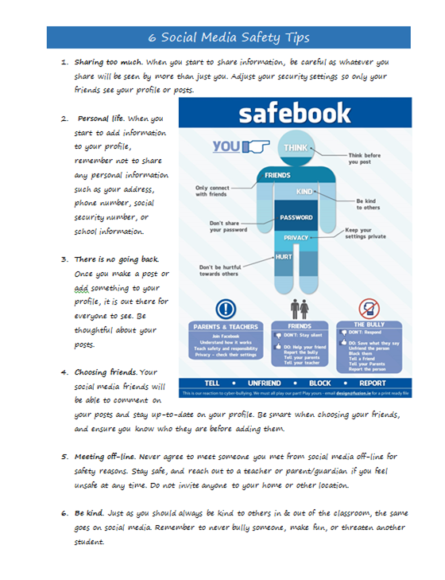 <http://dailygenius.com/printable-guide-will-keep-safe-social-media/>

Appendix E: Fakebook Resource Guide

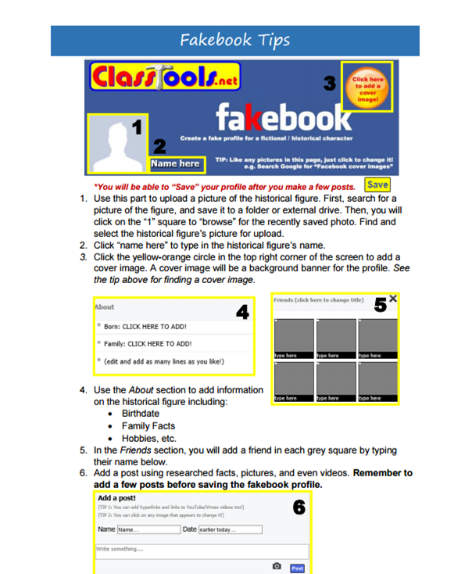

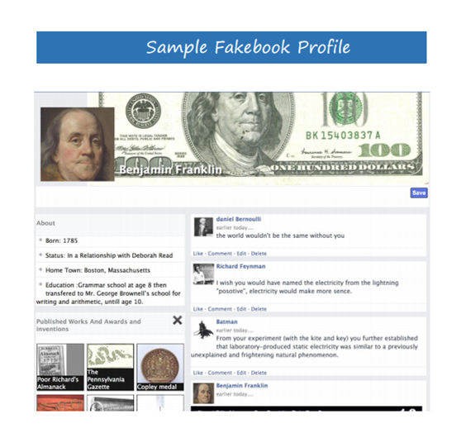

Appendix F

Fakebook Rubric

Task Description: Each student will create a Fakebook page using the criteria outlined below and in the workshop. The final product will be graded using the following rubric.

Student Name: ____________________ Historical Figure Name: _____________________

|  |  |  |  |  |
| --- | --- | --- | --- | --- |
|  | Excellent | Competent | Missing/Needs work | Score |
| Entering historical figure’s name  (3 points) | **The historical figure’s full name was entered and spelled correctly. A nickname may have been included as well.**  **(2 points)** | **The historical figure’s name was entered but may have omitted parts of the name or spelled it incorrectly.**  **(1 point)** | **No historical figure’s name was added.**        **(0 points)** |  |
| Creating original posts  (4 points) | **The student created two or more posts related to significant historical events in their selected figure’s life.**    **(4 points)** | **The student created one post related to significant historical events in their selected figure’s life.**  **(1-3 points)** | **The student did not create any posts or posts created were not related to significant historical events in their selected figure’s life.**  **(0 points)** |  |
| Replying to posts  (4 points) | **The student replied to two or more posts, adding content that creates a dialogue about the referenced event.**    **(4 points)** | **The student replied to one post, adding content that creates dialogue about the referenced event.**      **(1-3 points)** | **The student did not create any replies or replies created were not related to dialogue about the referenced event.**  **(0 points)** |  |
| Cover photo and profile picture    (4 points) | **The student added both photos for the cover photo and profile picture and both photos were relevant.**  **(4 points)** | **The student added only one of the required photos, or one photo loaded was not relevant to the figure selected.**    **(1-3 points)** | **No photos were loaded, or neither photo was relevant to the figure selected.**      **(0 points)** |  |
| Historical information      (5 points) | **The student entered at least 5 pieces of historical information for the selected figure, such as birth/death, family, work, etc.**  **(5 points)** | **The student entered less than 5 pieces of historical information for the selected figure, such as birth/death, family, work, etc.**  **(1-4 points)** | **The student did not include any pieces of historical information for the selected figure.**    **(0 points)** |  |
| Friends  (5 points) | **The student entered at least 5 friends in the friends section of the page. Friends listed were accurate for the selected figure.**    **(5 points)** | **The student entered less than 5 friends in the friends section of the page, or friends entered were not accurate for the selected figure.**  **(1 -4 points)** | **No friends were entered, or those that were entered were not accurate for the selected figure.**    **(0 points)** |  |
| Saving/sharing page    (2 points) | **The student successfully saved the page and shared the URL with the instructor for review**    **(2 points)** | **`The student successfully saved the page but struggled with or was unable to share the URL with the instructor for review.**  **(1 point)** | **`The student did not save the page or share the URL with the instructor for review.**    **(0 points)** |  |
| Total |  |  |  | **/27** |
| **Comments:** | | | | |

Appendix G: Post-workshop Survey

Post Fakebook Workshop Learner Survey

Please circle one of the numbers, on a scale of 1-5, that gives your answer.

Not Clear Very Clear

1. Did you understand the introduction? 1 2 3 4 5

2. Did you understand the goal of 1 2 3 4 5

the workshop?

3. Did you understand how to get to 1 2 3 4 5

the website?

4. Did you understand how to add 1 2 3 4 5

information to your page?

5. Did you understand how to add 1 2 3 4 5

images to your post?

6. Did you understand how to create 1 2 3 4 5

a password?

7. Did you understand how to share 1 2 3 4 5

your Fakebook page with your teacher?

8. Please add comments as to what you liked:

9. Please add comments as to what needs to be improved:

References

Brooks, S. (2014). Connecting the past to the present in middle-level classroom: A comparative

case study. *Theory & Research in Social Education*. Vol. 42, pp. 65-91. DOI: 10.1080/00933104.2013.860068.

Daily Genius (2014). *The printable guide that will keep you safe on social media.*

Retrieved from: <http://dailygenius.com/printable-guide-will-keep-safe-social-media/>

Dick, W., Carey, L., & Carey, J. (2015). *The systematic design of instruction*. Upper Saddle

River, NJ: Pearson.

Edudemic (2015). *How teens are really using social media*. Retrieved from:

<http://www.edudemic.com/teens-are-really-using-social-media/>

Ertmer, P., & Ottenbreit-Leftwich, A. (2009). Teacher technology change: How knowledge,

beliefs and cultural interest. Journal of Research on Technology in Education, 42(3),

255-30.

Indiana Department of Education. Indiana Academic Standards for English/Language Arts.

Retrieved from: http://www.doe.in.gov/sites/default/files/standards/enla/k-5_ela_draft-7-7-14-et.pdf.

International Society for Technology in Education (ISTE). Retrieved from:

<http://www.iste.org/standards/iste-standards/standards-for-students>

Murphy, K., DePasquale, R., & McNamara, E. (2003). Meaningful Connections: Using

Technology in Primary Classrooms. *Young Children, 58* (6), 12-18.

Youngbauer, V. (2013). Application of media literacy and cultural studies in K-12 social studies curricula. *The Social Studies, 104*(5), 183-189.